Brightly Named an Industry Leader in Asset Investment Planning (AIP) Software by Independent Analyst Firm
Recognition represents the company’s commitment to deliver intelligent asset management and capital planning solutions to the global market
CARY, N.C. and LONDON, August 17, 2023 – Brightly Software, the global leader in intelligent asset management solutions, today announced it has been recognized as “a Leader” in the Verdantix Green Quadrant®: Asset Investment Planning Software 2023 report. In the report, Brightly is acknowledged for delivering advanced, all-around AIP software capabilities to the global market, including strengths in user interfaces, asset performance modelling, and long-term investment planning capabilities. The report also acknowledges Brightly’s momentum in financial resources, organizational resources, vision and commercial strategy, and partnerships.
Brightly recently celebrated the one-year mark since its acquisition by Siemens Smart Infrastructure (SI) to deliver superior performance and sustainability for built infrastructure. Together with Siemens, Brightly continues to invest in its portfolio of asset and energy management solutions and AIP software to support organizations in making smarter, data-driven decisions to improve asset outcomes.
“As organizations face economic pressures and a heightened emphasis on ESG, capital planning and operational efficiency remain critical for organizations to make strategic decisions about asset management, maintenance and capital investment. Efficiency is everything, and with our ability to predict asset performance over 1-100 years with non-linear optimizations and industry-specific deteriorations patterns, we’re supporting organizations in making optimal short- and long-term investment planning decisions,” said Kevin Kemmerer, chief executive officer at Brightly. “Being recognized as a Leader is validation of our mission to lead the way to a bright future.”
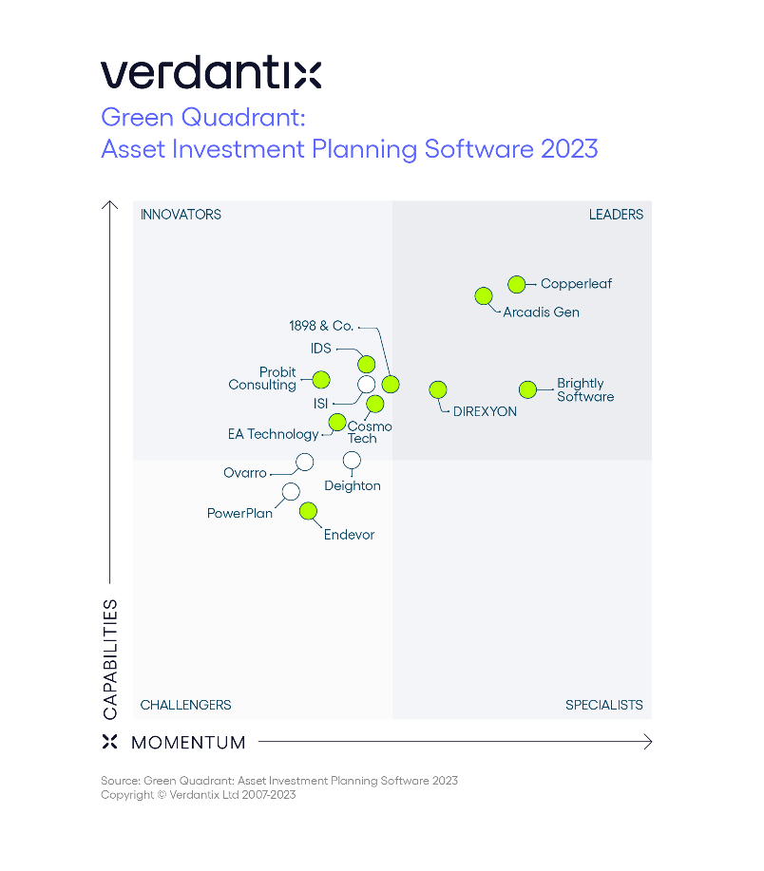
Analysis & Findings
This Verdantix Green Quadrant® report analyzes prominent AIP vendors in the market and surveys corporate users and operational efficiency decision makers. The analysis outlines key industry trends driving growth in the AIP space, including aging assets and the greater integration of KPIs within operational strategies and benefits such as improved decision-making, reduced risk, compliance with regulations and access to climate risk analysis (Source: Verdantix, Green Quadrant: AIP Software 2023). Based on market momentum and product capabilities within the Green Quadrant, Brightly earned a top position in the Leaders’ Quadrant.
“Spend on AIP software is set to grow, with providers looking to differentiate by offering end-to-end asset lifecycle capabilities, enhancing ESG capabilities, leveraging machine learning (ML) analytics, developing lightweight applications, upgrading usability and improving connectivity with other asset management solutions. Brightly Software, as a Leader in the market, is well positioned to deliver a strong AIP offering with visual what-if scenario modelling for custom long-term investment plans, test funding scenarios and manage budgets,” commented Kiran Darmasseelane, senior analyst, operational excellence at Verdantix.
“The landscape for AIP has rapidly evolved and the report’s analysis supports our work developing a solutions portfolio to address our global clients’ greatest asset management challenges,” said Brian Bell, senior vice president, strategy at Brightly. “We’re pleased to see our innovation efforts recognized by an independent analyst firm like Verdantix and we will continue to partner with organizations on their journey toward sustainable, asset lifecycle prediction and management.”
To learn more about the Verdantix “Green Quadrant: Asset Investment Planning Software 2023” report, visit www.verdantix.com. To learn more about Brightly’s offerings, visit: www.brightlysoftware.com.
About Brightly Software
Brightly, a Siemens company, enables organizations to transform the performance of their assets. As the global leader in intelligent asset management solutions, Brightly’s sophisticated cloud-based platform leverages more than 20 years of data to deliver predictive insights that help users through the key phases of the entire asset lifecycle. More than 12,000 clients of every size worldwide depend on Brightly’s complete suite of intuitive software – including CMMS, EAM, Strategic Asset Management, IoT Remote Monitoring, Sustainability and Community Engagement. Paired with award-winning training, support and consulting services, Brightly helps light the way to a bright future with smarter assets and sustainable communities. For more information, visit www.brightlysoftware.com.

