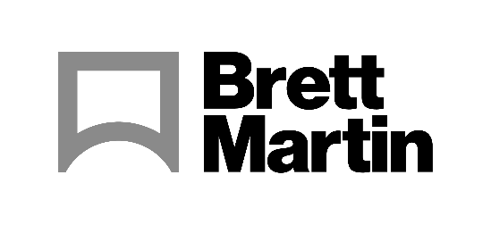

16th October 2023

Brett Martin collaborates with multiple approved partners at Printing United 2023
The best print and finishing equipment can only be shown off to its full potential when used with the best material, which is why some of the biggest names at Printing United 2023 (October 18-20th, Atlanta) will be printing to, and cutting, Brett Martin plastic sheets. Additionally, Brett Martin’s extensive product range will also be on display on its own stand: B11104.
Brett Martin’s Approved Partner Programme sees the Northern Ireland based plastics provider work closely with renowned printing and cutting machine manufacturers to test and showcase the capabilities of its semi-finished product portfolio. Many of these wide format print and finishing companies are partnering with Brett Martin at Printing United 2023.
Fujifilm is one of the newest members of the Approved Partner Programme, with the partnership first announced earlier this year at FESPA Global Print Expo 2023.
On stand B2506, Fujifilm will print to Brett Martin’s Foamalux Light Bio, and Foamalux Eco using some of the latest additions to its wide format range: the Acuity Prime Hybrid and the Acuity Ultra Hybrid. Applications printed will include signage, flat graphics, backlit applications and speciality projects.
Shaun Holdom, High End Marketing Manager, Fujifilm Wide Format Inkjet Systems, explains the importance of the collaboration. “To truly showcase any good machine, the material needs to be of a exceptional and consistent quality. That's why we selected to partner with Brett Martin. Additionally, sustainability remains at the forefront of their product development and operations, which is in line with Fujifilm’s very own values – making them an obvious choice of partner for us.”
At stand C2646, EFI will print on Foamalux White and Foamalux Colour, using its VUTEk h5 hybrid LED UV and Pro 30h UV flatbed printers.
On the HP stand (B13013), Foamalux Eco and Foamalux Light Bio will be showcased on the HP Latex R printer series.
Colex’s stand (B11113) will see Foamalux Xtra expertly cut using the Colex Sharpcut SX Series.
Mark Robinson, Brett Martin explains, “Printing United presents an excellent opportunity for us to showcase the limitless possibilities of print and the role that high-quality substrates play in achieving outstanding results. Our Approved Partners are a testament to our commitment to providing the finest quality substrates for the printing industry. Brett Martin’s substrates are known for superior printability, colour vibrancy, and durability. In collaboration with our key partners, we are able to demonstrate this via real applications.”
Brett Martin representatives will be on hand to discuss any queries at each Approved Partner’s stand, as well as on the Brett Martin stand (B11104).
To find out more about Brett Martin’s products, visit: www.brettmartin.com

ENDS
About Brett Martin:
UK-based Brett Martin employs over 1000 people across several locations throughout the UK and Europe and is a market leader in the manufacture of specialist plastic products for construction, roofing, engineering, print and display. The company exports over 50% of its £210 million turnover to more than 74 countries worldwide.

Further information:
Sirah Awan
AD Communications
Tel: + 44 (0) 1372 464470
Email: sawan@adcomms.co.uk

