27th March 2024

Fujifilm to showcase Jet Press FP790 water-based digital inkjet press for the flexible packaging print market at drupa 2024

First announced in 2021 with commercial availability formally announced at interpack 2023, the Jet Press FP790 is Fujifilm’s water-based digital inkjet press for the flexible packaging printing market. The Jet Press FP790 revolutionises the manufacturing process of flexible packaging for food and daily necessities by enabling short-run, diverse product variations, and short lead times which were previously unattainable with analogue printing.
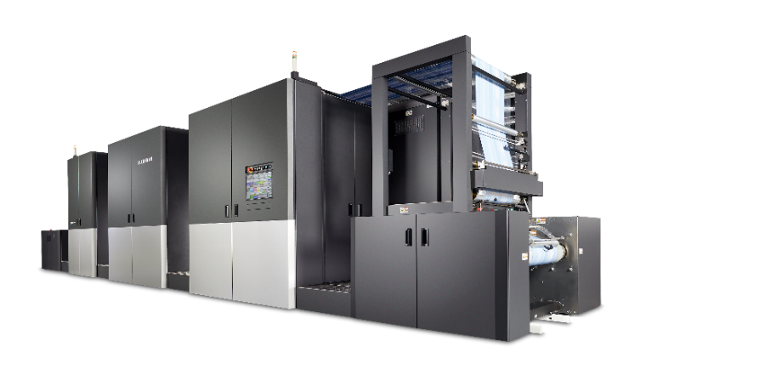

Jet Press FP790

In 2011, Fujifilm launched its flagship digital inkjet press, the Jet Press 720, which has since evolved to the Jet Press 750S. The Jet Press series has been highly acclaimed for its high image quality that surpasses offset printing, with over 300 installations worldwide. Leveraging its inkjet expertise and equipment sales know-how, accumulated in the commercial printing market, Fujifilm built on that heritage to produce the Jet Press FP790 for flexible packaging.

Within the flexible packaging printing market, the demand for short-run, diverse product variations, and short lead times has been increasing. Traditional analogue printing methods such as flexography and gravure printing have faced challenges to meet these needs, as they require significant time and costs to create plates, making it difficult to meet the short-run demand. On the other hand, digital printing technologies, including inkjet, are beginning to meet these demands.

The Jet Press FP790 enables high-speed printing at 50 metres per minute on film substrates of up to a maximum width of 790 mm, making it extremely productive as a digital printer and revolutionising the manufacturing process of flexible packaging.

In addition to CMYK print heads, it is equipped with two sets of white print heads. This improves the white opacity and enhances the colour saturation of the ink, allowing vibrant printing. It also has a mechanism to apply primer to the substrate before printing, providing high ink adhesion even on water-repellent film substrates. Furthermore, a print head resolution of 1200 dpi x 1200 dpi, makes high-resolution digital printing a reality.

Through pre-launch demonstration activities, the Jet Press FP790 has received favourable feedback from many customers and has already received orders from four companies in the emerging digital printing market for flexible packaging. Several customers have already started full operation, including Eco Flexibles, a highly sustainable flexible packaging converter in the UK, which began trial operations in August last year. Following the satisfactory conclusion of that trial, they have been so impressed with the press, that they have also agreed to install a second press in the near future to enhance productivity still further.

Fujifilm will continue to develop and provide groundbreaking products to the rapidly digitising printing market, contributing to the advancement of the global printing industry.

^{*1} BOPP film and PET film are compatible base materials for this product.

ENDS

About FUJIFILM Corporation
FUJIFILM Corporation is one of the major operating companies of FUJIFILM Holdings. Since its founding in 1934, the company has built up a wealth of advanced technologies in the field of photo imaging, and in line with its efforts to become a comprehensive healthcare company, Fujifilm is now applying these technologies to the prevention, diagnosis and treatment of diseases in the Medical and Life Science fields. Fujifilm is also expanding growth in the highly functional materials business, including flat panel display materials, and in the graphic systems and optical devices businesses.

About FUJIFILM Graphic Communications Division
FUJIFILM Graphic Communications Division is a stable, long-term partner focussed on delivering high-quality, technically advanced print solutions that help printers develop competitive advantage and grow their businesses. The company’s financial stability and unprecedented investment in R&D enable it to develop proprietary technologies for best-in-class printing. These include pre-press and pressroom solutions for offset, wide-format and digital print, as well as workflow software for print production management. Fujifilm is committed to minimising the environmental impact of its products and operations, proactively working to preserve the environment, and strives to educate printers about environmental best practice. For more information, visit fujifilmprint.eu, or youtube.com/FujifilmGSEurope or follow us on @FujifilmPrint.

For further information contact:
Daniel Porter
AD Communications
E: dporter@adcomms.co.uk
Tel: +44 (0)1372 464470

