27th March 2024

Fujifilm Group to showcase the world's first B2 full colour dry toner digital press, Revoria Press GC12500 at drupa 2024

Fujifilm Group will showcase its world’s first B2 full colour dry toner digital press – the Revoria Press GC12500, for the first time in an international exhibition in Europe at drupa 2024 in the commercial print area of the Fujifilm stand.
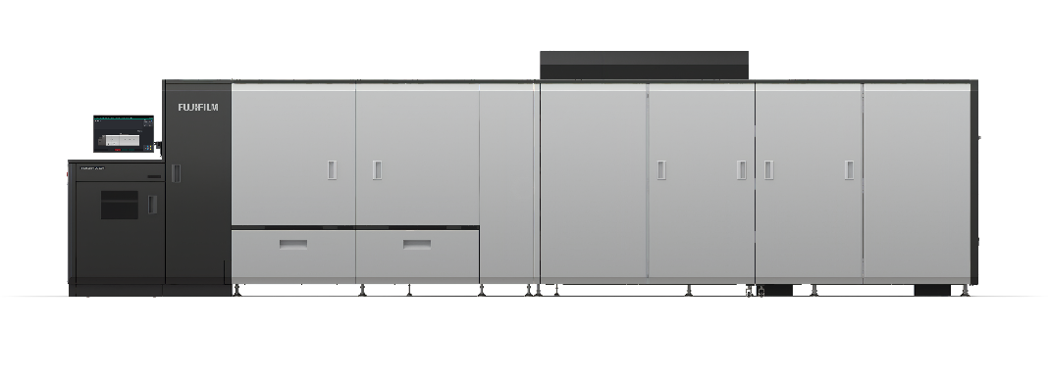
Fujifilm Group has sold over 300 of its B2 sheet-fed digital presses - the Jet Press 750S, which boasts industry-leading image quality and printing speeds.

The addition of the newly released Revoria Press GC12500 to Fujifilm’s Revoria range means that customers now have a dry toner B2 size printing option, in addition to A3. This product offers high production efficiency, user-friendly operation, and media versatility.

The GC12500 supports the largest size available in the current digital B2 printer market, B2XL size^{*1} (750 mm x 662 mm) paper. It can print up to six A4-sizes in a sheet, delivering high productivity of 250 ppm with A4. The press is capable of printing on small sized applications and large-format applications, such as posters. Additionally, consolidating the paper feeder/stacker and machine control panel in one place significantly improves the daily work efficiency and productivity for printing operators.
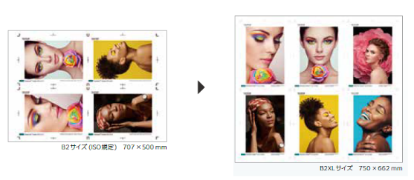

The printer was developed to enable B2 printing on demand without the need for specialised operators. Furthermore, Fujifilm has improved maintenance capabilities and optimised routine operations to minimise downtime.
Printing on B2 paper with dry toner has its challenges, but Fujifilm has incorporated proprietary new technology to overcome this. By developing new mechanisms for the fuser unit and developing unit, the stress on the paper during the printing process is reduced, improving image quality. With this new technology, the maximum paper size can be expanded to B2XL while also enabling automatic duplex printing on paper weights ranging from 64 gsm to 450 gsm. Combined with the wide media versatility^{*2} inherent to dry toner, a broad range of applications can be produced.
Fujifilm Group will exhibit at drupa 2024 where its Revoria PressTM GC12500 will be showcased alongside Fujifilm’s comprehensive product portfolio.

*¹ Paper size newly defined by FUJIFILM Group, which exceeds the standard B2 size (728 x 515 mm).
*² Some restrictions apply.

ENDS

About FUJIFILM Corporation
FUJIFILM Corporation is one of the major operating companies of FUJIFILM Holdings. Since its founding in 1934, the company has built up a wealth of advanced technologies in the field of photo imaging, and in line with its efforts to become a comprehensive healthcare company, Fujifilm is now applying these technologies to the prevention, diagnosis and treatment of diseases in the Medical and Life Science fields. Fujifilm is also expanding growth in the highly functional materials business, including flat panel display materials, and in the graphic systems and optical devices businesses.

About FUJIFILM Graphic Communications Division
FUJIFILM Graphic Communications Division is a stable, long-term partner focussed on delivering high-quality, technically advanced print solutions that help printers develop competitive advantage and grow their businesses. The company’s financial stability and unprecedented investment in R&D enable it to develop proprietary technologies for best-in-class printing. These include pre-press and pressroom solutions for offset, wide-format and digital print, as well as workflow software for print production management. Fujifilm is committed to minimising the environmental impact of its products and operations, proactively working to preserve the environment, and strives to educate printers about environmental best practice. For more information, visit fujifilmprint.eu, or youtube.com/FujifilmGSEurope or follow us on @FujifilmPrint.

For further information contact:
Daniel Porter
AD Communications
E: dporter@adcomms.co.uk
Tel: +44 (0)1372 464470

