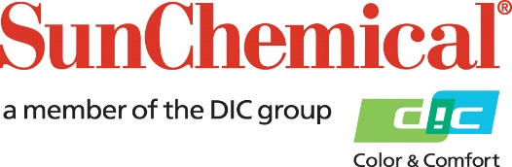

PR Contacts:
Begoña Louro, Sun Chemical Sirah Awan AD Communications, UK
+49 (0)152 2292 2292 +44 (0)7425 345 854
begona.louroluana@sunchemical.com sawan@adcomms.co.uk

Sun Chemical launches pigment ink for Direct-to-Film market, Xennia Jade

SOUTH NORMANTON, UK – 11th March 2024 – Sun Chemical today announced the launch of Xennia Jade, a pigment ink that meets the escalating demands of the direct-to-film (DTF) market. The solution has been specifically designed to address key challenges faced by DTF users within this market, providing a high-quality, stable, and reliable ink set for seamless daily, weekly, and monthly production.

Xennia Jade will be showcased at FESPA (Stand G41, Hall 5) in the RAI Amsterdam Convention Centre in Netherlands, from 19-22 March, allowing industry professionals to experience first-hand the features that make it an ideal choice for the evolving needs of the DTF market.

The DTF market has experienced unprecedented growth over the past two years, underscoring the need for innovative solutions to address the evolving demands of the industry. Existing industry solutions present some challenges with reliability and performance. Recognising the importance of consistent performance, Sun Chemical has dedicated considerable time and resources to develop a comprehensive solution tailored to meet the specific needs of the market.

Sun Chemical’s commitment to enhance print quality and user experience is underlined with Xennia Jade white, a product advancement offering high opacity ink with reduced maintenance requirements. When combined with the high colour strength CMYK set, users can benefit from the best in application performance, enabling the ability to print across a full range of coloured substrates, including black shirts. Xennia Jade can be used with commercially available resin powders, however the Xennia Jade range also incorporates a powder adhesive for optimal application and abrasion resistance. Xennia Jade can also be used across a range of non-textile substrates, showcasing its potential to be used in various industries.

Edri Baggi, Business Manager for Sun Chemical’s Textile Inks Business comments: “With the launch of Xennia Jade, we have taken a meticulous approach, dedicating time to ensure a high-quality and reliable ink. Our interaction with customers played a pivotal role in assisting us to create the new pigment ink. We engaged in meaningful conversations, understanding their specific needs and pain points with the technology, as well as sustainability and safety considerations. The result is a solution crafted to address as many of these concerns as possible, to elevate the application space to new heights."
ENDS

About Sun Chemical
Sun Chemical, a member of the DIC Group, is a leading producer of packaging and graphic solutions, color and display technologies, functional products, electronic materials, and products for the automotive and healthcare industries. Together with DIC, Sun Chemical is continuously working to promote and develop sustainable solutions to exceed customer expectations and better the world around us. With combined annual sales of more than $8.5 billion and 22,000+ employees worldwide, the DIC Group companies support a diverse collection of global customers.

Sun Chemical Corporation is a subsidiary of Sun Chemical Group Coöperatief U.A., the Netherlands, and is headquartered in Parsippany, New Jersey, U.S.A. For more information, please visit our website at www.sunchemical.com or connect with us on LinkedIn, or Instagram.

