**28th May 2024**

**Fujifilm announces the new Acuity Triton using the AQUAFUZE technology**

Following the announcement of the revolutionary water-based UV patented ink technology AQUAFUZE from Fujifilm Group, the technical preview of the new Acuity Triton, 1.6m width printer will be done, at drupa (Hall 8b / A02).



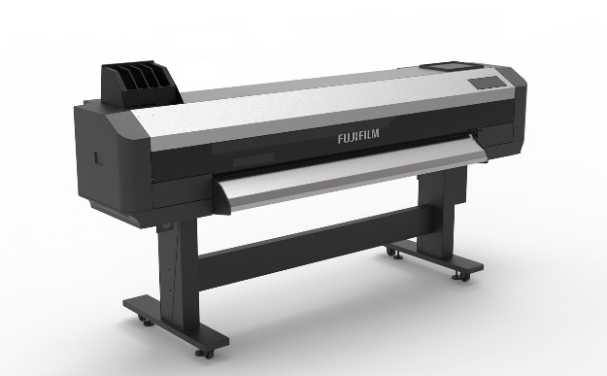

The Acuity Triton project brings together two titans of the wide format inkjet industry. The hardware is manufactured in Japan by Mutoh, whose reputation for building quality driven, reliable inkjet printers over the last 20 years is outstanding. The AQUAFUZE ink has been developed and produced by Fujifilm, drawing on its unparalleled track record of ink innovation.

Acuity Triton is the ideal pairing for the AQUAFUZE ink technology to support its vast range of applications with excellent print results for this market space.

AQUAFUZE technology meets a multitude of market requirements by combining the benefits of UV LED and water-based inkjet. It has low-energy, low temperature drying compared to traditional water-based print systems. It provides excellent adhesion to a wide range of media without the need for a pre-coat primer or optimiser. Prints have a thin film, that is scratch-resistant and does not require a top-coat. In addition, they are low-odour and safety compliant. The technology offers excellent jetting stability through reduced nozzle blocking due to low temperature drying.

In a saturated market, it was high time a revolutionary technology broke into this space to offer wide format print companies a real differentiator in productivity and all-round performance, and this with sustainability in mind. We believe this breakthrough technology is just the step forward the print industry needs. This is a first step of Fujifilm to establish a new WFIJ inkjet ink standard in the market.

**ENDS**

**About FUJIFILM Corporation**

FUJIFILM Corporation is one of the major operating companies of FUJIFILM Holdings. Since its founding in 1934, the company has built up a wealth of advanced technologies in the field of photo imaging, and in line with its efforts to become a comprehensive healthcare company, Fujifilm is now applying these technologies to the prevention, diagnosis and treatment of diseases in the Medical and Life Science fields. Fujifilm is also expanding growth in the highly functional materials business, including flat panel display materials, and in the graphic systems and optical devices businesses.

**About FUJIFILM Graphic Communications Division**

FUJIFILM Graphic Communications Division is a stable, long term partner focussed on delivering high-quality, technically advanced print solutions that help printers develop competitive advantage and grow their businesses. The company’s financial stability and unprecedented investment in R&D enable it to develop proprietary technologies for best-in-class printing.  These include pre-press and pressroom solutions for offset, wide-format and digital print, as well as workflow software for print production management. Fujifilm is committed to minimising the environmental impact of its products and operations, proactively working to preserve the environment, and strives to educate printers about environmental best practice. For more information, visit fujifilmprint.eu or [youtube.com/FujifilmGSEurope](http://www.youtube.com/FujifilmGSEurope) or follow us on @FujifilmPrint.

**For further information contact:**

Daniel Porter

AD Communications

E: [dporter@adcomms.co.uk](mailto:dporter@adcomms.co.uk)

Tel: +44 (0)1372 464470