**28th May 2024**

**Fujifilm Group Boost Business Growth with New Production Presses and Specialty Colour Capabilities**

*Achieve vibrant print applications, work versatility and enhanced productivity with next generation technology*

Fujifilm Group announces the launch of four new mid-range production presses in the Revoria PressTM series globally. The Revoria PressTM EC2100S and Revoria PressTM SC285S are equipped with a specialty toner station*1 in addition to the four-colour toners, enabling five-colour printing in one pass. the Revoria PressTM EC2100 and Revoria PressTM SC285 are four-colour presses. All four products are compact in size with high print quality and speed. Worldwide sales will begin from December 2024 onwards.

The Revoria PressTM series was launched in July 2021. The flagship model, the Revoria PressTM PC1120 caters to the high-end professional market, offers a one-pass six colour print engine of up to two specialty toners, print resolution of 2400 dpi, high-speed printing at 120 pages per minute and high image quality printing with Super EA-Eco toner which has one of the smallest toner particle sizes in the industry. With its high image quality, superior productivity, and value-added creation through specialty colour printing, the Revoria PressTM PC1120 is leading the production printing market globally in Europe, the United States, and the Asia-Pacific.

The Revoria PressTM EC2100S and Revoria PressTM EC2100 print at a high speed of 100 pages per minute*2 and are primarily utilised for an extensive range of commercial printing and quick printing. While the Revoria PressTM SC285S and Revoria PressTM SC285 with a printing speed of 85 pages per minute*2 are utilised for quick printing and in-house printing.

The products can handle an expansive range of paper weights from lightweight 52 gsm to heavyweight 400 gsm*3, and paper sizes, from a minimum of 90 x 146 mm up to 330 x 1300 mm*4 without reducing its printing speed. Equipped with a new feature, Smart Monitoring Gate D1*5, it detects colour variation and front-to-back misalignment during printing, enabling automatic correction in real time to maintain high print quality without compromising on productivity. To generate high-quality images and smooth workflows, there will be two choices of Revoria FlowTM and Fiery print servers available. With the newly developed vertical toner development system that can contribute to maintain compact machine size, users can now produce premium quality printed materials, even when working with a wide variety of products, small lots, and short delivery times, such as catalogues, brochures, manuals, and sales promotion materials.

At our stand at drupa, we will be exhibiting the "EC2100S" and "SC285S" printers, which are capable of 5-colour printing. As a special feature, we have incorporated a pink colour that expands the colour gamut and vividly expresses skin tones. You will be able to compare the difference in output between 4-colour printing and this enhanced representation of colours. We will also showcase the "Smart Monitoring Gate D1" providing real-time demonstration of correction processes. We invite you to experience the improved reproductions of image quality, and other finer details of our 4-colour print samples, as well as the expressive capabilities of the 5-colour option.

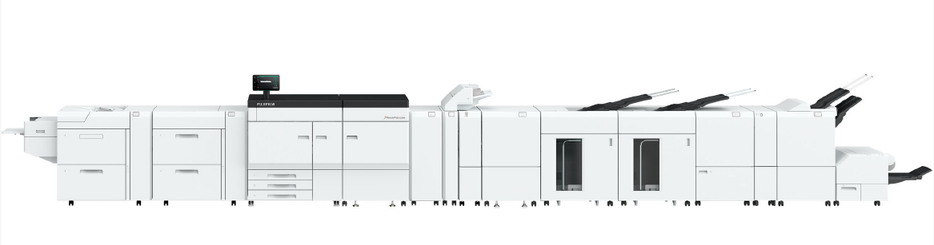

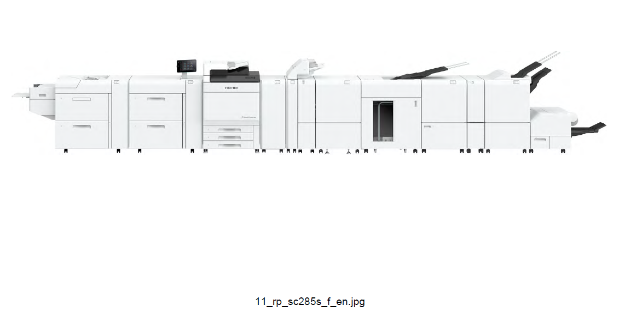

Revoria PressTM EC2100S / EC2100

Revoria PressTM SC285S / SC285

**【Main Features of the New Products】**

1. **Revoria PressTM EC2100S / SC285S (available to both products)**

* Equipped with a one-pass five-colour print engine, one specialty toner can be used in addition to the CMYK toners. Full range of support functions are available for easy utilisation of specialty colours.
* A variety of specialty toners are available in Clear, Pink, Custom Red, Gold, and Silver. A variety of metallic colours can be expressed by mixing highly brilliant Gold and Silver toners with CMYK toners.
* The image data is automatically divided into five colours of CMYK and Pink on the Revoria FlowTM and Fiery print servers.
* Designs can be created while checking the expression of specialty colours with the preview function. Users can save time and effort for test printing.
* Users can easily change the specialty toner with less man-hours*5.

1. **Revoria PressTM EC2100S / EC2100 / SC285S / SC285 (available to all four products)**

* Efficient space utilisation with compact LED printhead and high-resolution print at 2400 dpi.
* Increase work productivity through the high-speed printing. The Revoria PressTM EC2100S / EC2100 print at 100 pages per minute, while the Revoria PressTM SC285S / SC285 print at 85 pages per minute.
* Versatile media handling for a wide range of applications.
  + The compact belt roll fuser enables high-quality printing on textured paper.
  + Equipped with an Air Suction Feeder*6 that ensures reliable feeding of coated paper, which tends to stick to the paper. The Static Eliminator D1*6 removes static electricity from film paper and other static-sensitive printing paper, enabling reduction of adhesion between sheets of paper for work efficiency.
  + The machine also supports paper output such as envelopes, water-resistant paper, and cardboard for packaging.
* The Print Inspection System*6 inspects printed materials automatically and in real time to detect printing defects such as dots, stains, pinholes, streaks, and paper folds. The system inspects readability of characters and barcodes, numbering information continuity and front/back characters and numbering continuity.
* The Revoria PressTM EC2100S / EC2100 will be compatible with Revoria FlowTM and Fiery® EC21 / EC22 servers. Similarly, the Revoria PressTM SC285S / SC285 will be compatible with Revoria FlowTM and Fiery® SC21 / SC22C servers. Customers can choose from several options of print servers to meet their needs.

*1: Clear, Pink, Custom Red, Gold and Silver for specialty toners. Availability of Gold and Silver will be announced later.

*2: Paper weight 52-400 gsm, when running A4 uncoated paper, when using CMYK colour.

*3: When the using of Air Suction Feeder.

*4: Requires optional installation of a paper feed / release tray that supports long sheet printing.

*5: For colour replacement of specialty toner, prior training is required.

*6: User can add-on this optional solution to be installed in the presses.

**ENDS**

**About FUJIFILM Corporation**

FUJIFILM Corporation is one of the major operating companies of FUJIFILM Holdings. Since its founding in 1934, the company has built up a wealth of advanced technologies in the field of photo imaging, and in line with its efforts to become a comprehensive healthcare company, Fujifilm is now applying these technologies to the prevention, diagnosis and treatment of diseases in the Medical and Life Science fields. Fujifilm is also expanding growth in the highly functional materials business, including flat panel display materials, and in the graphic systems and optical devices businesses.

**About FUJIFILM Graphic Communications Division**

FUJIFILM Graphic Communications Division is a stable, long term partner focussed on delivering high-quality, technically advanced print solutions that help printers develop competitive advantage and grow their businesses. The company’s financial stability and unprecedented investment in R&D enable it to develop proprietary technologies for best-in-class printing.  These include pre-press and pressroom solutions for offset, wide-format and digital print, as well as workflow software for print production management. Fujifilm is committed to minimising the environmental impact of its products and operations, proactively working to preserve the environment, and strives to educate printers about environmental best practice. For more information, visit fujifilmprint.eu or [youtube.com/FujifilmGSEurope](http://www.youtube.com/FujifilmGSEurope) or follow us on @FujifilmPrint.

**For further information contact:**

Daniel Porter

AD Communications

E: [dporter@adcomms.co.uk](mailto:dporter@adcomms.co.uk)

Tel: +44 (0)1372 464470