**28th May 2024**

**Fujifilm introduces a new addition to the Acuity Ultra Hybrid family, with automation**

Fujifilm is pleased to preview its third generation Acuity Hybrid, the NEW Acuity Ultra Hybrid Pro at drupa (Hall 8b / A02).

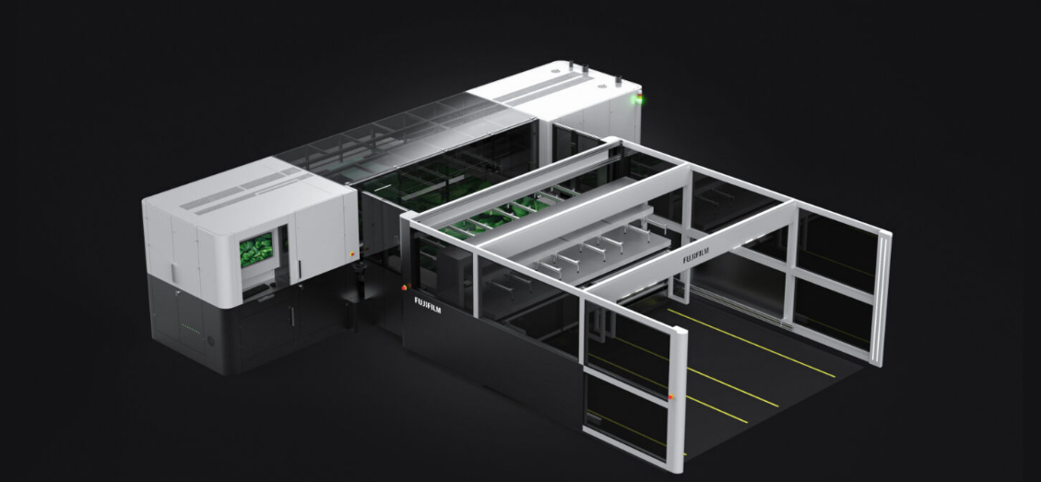

Just as with the others in the line-up, a 3.5 picolitre drop sizes is achieved with a double size carriage, and print speeds are in excess of 600 m²/per hour (in excess of up to 100 8 x 4ft boards per hour).

The Acuity Ultra Hybrid Pro uses patented Fujifilm ink technology that adheres to a wide variety of media and is especially designed for rigid and roll substrates.

To support high volume production, the new Acuity Ultra Hybrid Pro can be seamlessly integrated with a new automation system. This system is designed for the automatic handling of rigid materials, allowing one single operator to run the machine for a full pallet-to-pallet process.

The robust design of the automation system not only speeds up production, but also has the option of using half or full automation. The automation system has a loading option to feed material to the printer and an unloading system to unload the material from the printer to a pallet.

We are proud to preview at drupa 2024 the next generation in our Acuity family, the Acuity Ultra Hybrid Pro with automation options. At Fujifilm we have confidence in listening to our customers and the market to provide solutions that grow with your business.

**ENDS**

**About FUJIFILM Corporation**

FUJIFILM Corporation is one of the major operating companies of FUJIFILM Holdings. Since its founding in 1934, the company has built up a wealth of advanced technologies in the field of photo imaging, and in line with its efforts to become a comprehensive healthcare company, Fujifilm is now applying these technologies to the prevention, diagnosis and treatment of diseases in the Medical and Life Science fields. Fujifilm is also expanding growth in the highly functional materials business, including flat panel display materials, and in the graphic systems and optical devices businesses.

**About FUJIFILM Graphic Communications Division**

FUJIFILM Graphic Communications Division is a stable, long term partner focussed on delivering high-quality, technically advanced print solutions that help printers develop competitive advantage and grow their businesses. The company’s financial stability and unprecedented investment in R&D enable it to develop proprietary technologies for best-in-class printing.  These include pre-press and pressroom solutions for offset, wide-format and digital print, as well as workflow software for print production management. Fujifilm is committed to minimising the environmental impact of its products and operations, proactively working to preserve the environment, and strives to educate printers about environmental best practice. For more information, visit fujifilmprint.eu or [youtube.com/FujifilmGSEurope](http://www.youtube.com/FujifilmGSEurope) or follow us on @FujifilmPrint.

**For further information contact:**

Daniel Porter

AD Communications

E: [dporter@adcomms.co.uk](mailto:dporter@adcomms.co.uk)

Tel: +44 (0)1372 464470