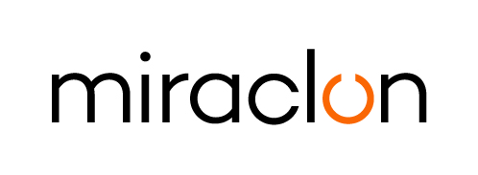
Press Release

Media Contact:
Elni Van Rensburg - +1 830 317 0950 – elni.vanrensburg@miraclon.com
Josie Fellows – +44 (0)1372 464470 – jfellows@adcomms.co.uk

May 31st, 2024

Numex Blocks becomes first in Asia to make investment in
two SHINE LED Lamp Kits, innovated by Miraclon

Mumbai-based trade shop, Numex Blocks, has become the first in Asia to invest in SHINE LED Lamp Kits, innovated by Miraclon. Owner Nitin Patel made the final decision to invest in SHINE LED Lamps to retrofit to his two exposure units at drupa 2024, and says “the faster exposure times, better plate consistency, reduced waste and obvious cost benefit of not having to replace the two exposure units with new ones, made it an easy decision.”

The company has, over the years, continuously invested in new, leading-edge technologies to ensure it keeps its competitive advantage as a leading flexo-focused trade shop. “We like to keep abreast of the latest technology to ensure we keep growing. When Miraclon, who we’ve been enjoying a long, consultative relationship with, introduced us to SHINE LED Lamps, I was very excited about the easy path it offered us to simply and quickly retrofit our existing fluorescent devices with LED lamps instead of having to make a significant investment in new ones.”

He continues: “The investment will also deliver a good range of sustainability and productivity benefits: we’ll be able to significantly cut exposure times by around 20%, which allows for big energy savings!”

The Shine LED Lamp Kit is Miraclon’s innovative solution to providing fluorescent users with a simple, low-cost route from inconsistent fluorescent exposure to the multiple advantages of LED technology. By utilizing customers’ existing fluorescent exposure frames, for a fraction of the cost of a new LED exposure unit users benefit from consistent, predictable intensity over a much longer operating life (up to 5,000 hours compared to 800 hours for fluorescent tubes), faster exposures, and enhanced sustainability performance. These features won the Shine LED Lamp Kit a unique double at this year’s FTA Excellence in Flexography Awards, winning top awards for both Sustainability and Technical Innovation.

ENDS

About Miraclon
Miraclon is the home of FLEXCEL Solutions, which have helped transform flexographic printing for more than a decade. The technology, including the industry-leading FLEXCEL NX and FLEXCEL NX Ultra Systems, and FLEXCEL NX Print Suite that enables PureFlexo™ Printing, maximizes on-press efficiency, delivers higher quality and overall best-in-class results. With a focus on pioneering image science, innovation, and collaboration with industry partners and customers, Miraclon is committed to the future of flexo and continues to be positioned to lead the charge. Find out more at www.miraclon.com, and follow us on LinkedIn and YouTube.

