4th June 2024

Women in Print Issue: Women and the Machine
The new issue of Fujifilm's 'Women4Women' magazine is being printed live at drupa 2024 on the Fujifilm stand, giving a female glance at the world of printing and graphic arts.
Fujifilm is presenting the new issue of Women4Women magazine to honour women in the print and graphic industries. This new edition has been designed with a completely new look and feel and is being published to coincide with the world's leading print technology exhibition, drupa (Düsseldorf, Germany 28th May - 7th June). The magazine is being printed on the Jet Press 1160CFG at the Fujifilm stand (Hall 8b, Stand A02) during the show.
More than 20 women from all over the world, from Australia to the UK, shared their stories and experiences in an industry that until 1876, the year the Women's Printing Society was founded, was the prerogative of men. The shots of Turin photographer Paola Agosti, taken in some factories in Italy in the 1980s, accompany the reader on a journey in colour and black and white to discover 'women and the machine'.
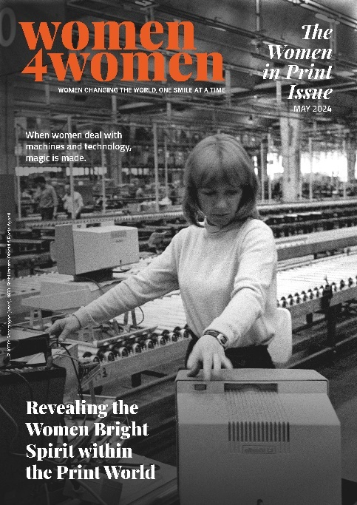
Starting with this edition, the magazine has been given a new look together with a significant restyling of the logo and layout.
In line with the company's new corporate purpose 'Giving our world more smiles', the magazine has been given a new tagline, 'Women changing the world, one smile at a time', emphasising issues such as diversity, equality and inclusion.
Underlining these values, Fujifilm Europe President Yoshiki Kimura said: "Our goal is to bring together diverse ideas, unique skills and extraordinary people to change the world. Women4Women is a concrete example that testifies to the path we have taken towards Diversity, Equity and Inclusion."
"The stories we have collected in this new issue are all about a challenge," says Luana Porfido, European Head of Corporate Communication and ESG Management FUJIFILM Europe GmbH. "A challenge that has been quietly but not yet fully recognised, one that sees women and machines progressing and evolving together, demonstrating that technology, in this case applied to the printing industry, is not a men-only activity. These magnificent women tell us how they are able to create empathy with these mechanical 'hearts' and thanks to the strong 'bond' that is created, it has been possible to achieve results that we can be described as artistic. Business aptitude is not enough to do this."
Among the external contributors is Lisa Farinati, Head of Business Administration at Faservice Srl, a Veneto-based graphic arts company founded in 1966. For this incredible woman, female leadership can be the key to positive change because every experience and every achievement is reflected in the working world, creating a unique mix of innovation and dedication. Writing has always been the great passion of Chiara Bezzi, Editorial Manager of Innovative Press. For 20 years she has been working as a journalist in the graphic arts sector, reporting on market trends, evolving technologies and the stories of excellent companies such as those led by female entrepreneurs who have been able to direct their corporate focus towards sustainability, inclusion and the enhancement of all human resources. Or Ms. Zhu Min, Vice President C&C Joint Printing Co. (Hong Kong) Ltd., who received the "Bi Sheng Printing Outstanding Achievement" award, the highest technical award in the printing industry in China, after gaining extensive experience in the field.
The souls of Fujifilm are represented by several contributors, starting with Makiko Numata, working for the Graphic Communication Division for FUJIFILM Business Innovation Corp., who talks about how her dedication to the performing arts drives her to seek out the 'work of art' to create incredible images and prints for customers. The printing industry is not a strongly female-dominated sector, and according to Mihoko Endo, also working for the Graphic Communication Division for FUJIFILM Business Innovation Corp., women can provide significant support. She believes in a future without gender boundaries and personally intends to contribute to the creation of products that can be used by anyone regardless of age or skills.
The role of Isabelle Katrina Morales, Regional Technical Product Specialist at FUJIFILM Business Innovation in Malaysia, requires the determination and courage to overcome long-established barriers. And this is what drives her to constantly update herself on new printing technologies and study to develop innovative new technical materials and grow within the company.
It is no coincidence that the release of 'The Women in Print Issue' coincides with Fujifilm's participation in drupa, the world's leading print technology exhibition, highlighting the incredible contribution that women have made within this industry. During the show, Fujifilm will present its credentials as a reliable and sustainable partner, adding value to print businesses. (Hall 8b / A02)
Click here to browse the new issue of Women4Women and previous editions:
https://www.fujifilm.com/it/it/women4women

ENDS

About FUJIFILM Corporation
FUJIFILM Corporation is one of the major operating companies of FUJIFILM Holdings. Since its founding in 1934, the company has built up a wealth of advanced technologies in the field of photo imaging, and in line with its efforts to become a comprehensive healthcare company, Fujifilm is now applying these technologies to the prevention, diagnosis and treatment of diseases in the Medical and Life Science fields. Fujifilm is also expanding growth in the highly functional materials business, including flat panel display materials, and in the graphic systems and optical devices businesses.

About FUJIFILM Graphic Communications Division
FUJIFILM Graphic Communications Division is a stable, long-term partner focussed on delivering high-quality, technically advanced print solutions that help printers develop competitive advantage and grow their businesses. The company’s financial stability and unprecedented investment in R&D enable it to develop proprietary technologies for best-in-class printing. These include pre-press and pressroom solutions for offset, wide-format, and digital print, as well as workflow software for print production management. Fujifilm is committed to minimising the environmental impact of its products and operations, proactively working to preserve the environment, and strives to educate printers about environmental best practice. For more information, visit fujifilmprint.eu or at youtube.com/FujifilmGSEurope or follow us at @FujifilmPrint.

For further information contact:
Daniel Porter
AD Communications
E: dporter@adcomms.co.uk
Tel: +44 (0)1372 464470

