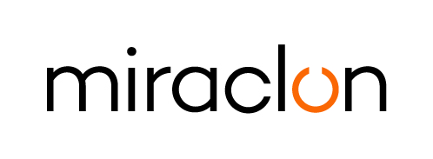
Media Alert

Media Contact:
Elni Van Rensburg – +1 830 317 0950 – elni.vanrensburg@miraclon.com
Aimee Parsons - +44 (0)1372 464470 – aparsons@adcomms.co.uk

March 11, 2025

Flexocolor invests in large format FLEXCEL NX System to address growing market demand

Leading French trade shop, Flexocolor, has invested in a FLEXCEL NX 5080 System from Miraclon, expanding the FLEXCEL NX Plate format size that the company has been offering its customers for the past eight years. The new FLEXCEL NX System was installed at Flexocolor’s premises near Limoges in February.

According to Mathieu Grimeaud, Associate Director at Flexocolor, “the larger FLEXCEL NX System enables us to meet the growing printer demand for FLEXCEL NX Plates across a broader range of flexible packaging, adhesive label and corrugated applications. Additionally, it allows us to optimize plate layouts, thereby reducing wastage. This is a strategic investment that greatly enhances our business operations.”

The FLEXCEL NX 5080 System offers flexo printers the advantages of modern flexo by improving efficiencies across the print production process. Printers that implement modern flexo benefit from increased uptime, less troubleshooting, reduced waste and more efficient job scheduling.

ENDS

About Miraclon
At Miraclon, we have one clear mission - to transform flexographic printing in partnership with our customers by delivering leading technology and expertise that enables them to achieve their efficiency, sustainability and quality goals. Our unique, fully integrated FLEXCEL plate solutions eliminate production variables and deliver the 100% precision required for optimized ink transfer: the foundation of modern flexo printing. Our dedicated team helps customers achieve business success by realizing the full potential of their investment in Miraclon technology. Find out more at www.miraclon.com, and follow us on LinkedIn and YouTube.

