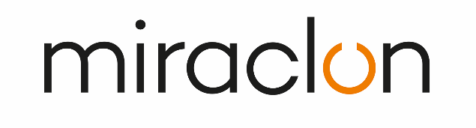
Customer Testimonial
Media Contact:
Elni Van Rensburg – +1 830 317 0950 – elni.vanrensburg@miraclon.com
Aimee Parsons - +44 (0)1372 464470 – aparsons@adcomms.co.uk

May 21, 2025

Omnicom drives adoption of FLEXCEL NX Technology in Greece with
ICR Ioannou S.A. leading the charge

ICR Ioannou S.A. has become the first company in Greece to invest in a FLEXCEL NX System and PureFlexo™ Printing from Miraclon, responding to growing demand for FLEXCEL NX Plates from flexographic printers in the region. The company signed the deal at drupa 2024, on a visit to the show with Omnicom - Miraclon’s local partner in Greece – and the system was installed at the end of last year in ICR Ioannou S.A. production site outside Athens.

Yiannis Ioannou, Managing Director of ICR Ioannou S.A., says the investment “addresses the increasing market demand we’ve had for FLEXCEL NX Plates. Our printer customers are seeking the productivity and sustainability benefits that FLEXCEL NX Technology delivers and how it enables them to implement modern flexo.”

He adds: “We included PureFlexo Printing in the investment after seeing first-hand how Miraclon’s multi-form patterning technology enables even cleaner printing as well as greater productivity on press. This ensures that we’re not only maximizing the capabilities of our investment, but also offering customers the additional on-press advantages that it delivers”.

A milestone for the packaging industry
“Having FLEXCEL NX Plates and PureFlexo Printing locally available is a big milestone for the packaging printing industry in Greece and the countries we are exporting to,” he continues. “FLEXCEL NX Plates offer guaranteed benefits for packaging printers: consistent, high-quality printing that meets even the most demanding brand standards; improved press efficiency with reduced touchpoints, waste, and rework; and more sustainable practices.”

A maturing market, now benefiting from local access to FLEXCEL NX Technology
Tina Papadimitriou of Omnicom adds “the Greek packaging market is maturing, so printers are focusing more and more on adopting modern flexo practices that enable better efficiency and sustainability like reduced stops and ink consumption, while producing high-end flexo applications. This calls for new, more diverse technology, which printers and converters previously had to source from abroad. Now they have a path to modern flexo with FLEXCEL NX Technology on their doorstep!”

ENDS

About ICR Iannou S.A.
To learn more about our services with cutting-edge technology, visit our website here

About Miraclon
At Miraclon, we have one clear mission - to transform flexographic printing in partnership with our customers by delivering leading technology and expertise that enables them to achieve their efficiency, sustainability and quality goals. Our unique, fully integrated FLEXCEL plate solutions eliminate production variables and deliver the 100% precision required for optimized ink transfer: the foundation of modern flexo printing. Our dedicated team helps customers achieve business success by realizing the full potential of their investment in Miraclon technology. Find out more at www.miraclon.com, and follow us on LinkedIn and YouTube.

