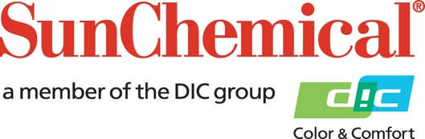

PR Contacts:
Begoña Louro, Sun Chemical Sirah Awan, AD Communications, UK
+49 152 2292 2292 +44 (0)1372 460542
begona.louro@sunchemical.com sawan@adcomms.co.uk

Sun Chemical Issues Autumn 2025 Regulatory Newsletter

SOUTH NORMANTON, UK – 8th October, 2025 – Sun Chemical has released its Autumn 2025 Regulatory Newsletter, which provides customers with updates on the latest regulatory issues impacting the packaging, inks and pigments industries.

The Autumn 2025 Regulatory Newsletter highlights the fast-moving landscape of chemical and packaging policy, with updates regarding European debates on chemical safety, food contact materials and microplastics, as well as legislative developments across North America and Asia.

“Through our biannual regulatory newsletter, we aim to provide clear, actionable insights on issues that directly affect our customers and their industries,” said Bob Kendrick, Director Corporate Regulatory, Sun Chemical. “By tracking developments across the world, we help our stakeholders stay ahead of changes and adapt their operations responsibly.”

Highlights from the Autumn 2025 edition include:
- European authorities continuing discussions on final limits for polychlorinated biphenyls (PCBs) under the Persistent Organic Pollutants (POPs) regulation.
- A coalition of scientists urging the European Commission to retain the proposed mixture assessment factor in the REACH revision.
- The European Food Safety Authority (EFSA) reassessing styrene and confirming its safety at existing migration limits for plastics in food contact materials.
- New reporting duties for industrial users of inks and varnishes under the European Union microplastics restriction, taking effect in 2025.
- India advancing mandatory recycled content targets for food contact plastics, while the United States Environmental Protection Agency (EPA) reopens its chemical risk evaluation framework.
- The Court of Justice overturning the classification of titanium dioxide as a carcinogen, while regulators propose strict classification for synthetic amorphous silica.

In addition to its regulatory newsletters, Sun Chemical produces annual sustainability reports showcasing products and services that enable customers to stay ahead of regulatory changes and deliver on business sustainability commitments. The latest report is available at www.sunchemical.com/sustainability.

Visit www.sunchemical.com/regulatory-newsletters/ to download a copy of Sun Chemical’s Autumn 2025 Regulatory Newsletter.

About Sun Chemical
Sun Chemical, a member of the DIC Group, is a leading producer of packaging and graphic solutions, color and display technologies, functional products, electronic materials, and products for the automotive and healthcare industries. Together with DIC, Sun Chemical is continuously working to promote and develop sustainable solutions to exceed customer expectations and better the world around us. With combined annual sales of more than $7.0 billion and 21,000+ employees worldwide, the DIC Group companies support a diverse collection of global customers.

Sun Chemical Corporation is a subsidiary of Sun Chemical Group Coöperatief U.A., the Netherlands, and is headquartered in Parsippany, New Jersey, U.S.A. For more information, please visit our website at www.sunchemical.com or connect with us on LinkedIn or Instagram.

