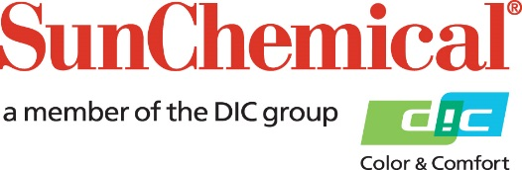

PR Contacts:
Begona Louro, Sun Chemical Sirah Awan, AD Communications, UK
+49 152 2292 2292 +44 (0)1372 460542
begona.louro@sunchemical.com sawan@adcomms.co.uk

Sun Chemical partners with Onlineprinters to optimise SunLit ProPace ink range
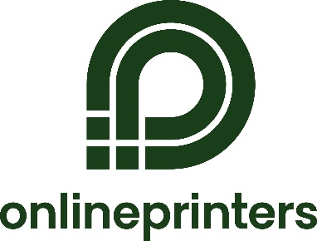
Sun Chemical has partnered with Onlineprinters, one of Europe’s largest online print providers, in the co-development and optimisation of the SunLit ProPace ink range – Sun Chemical’s latest vegetable oil-based, sheetfed process inks based on their novel PACE technology platform, designed to help printers boost productivity and increase sustainability credentials in commercial publication and non-food packaging printing. The SunLit ProPace ink range, now widely used across Onlineprinters’ production site in Germany, was formulated in continuous, close consultation with Online Printers to meet the stringent print quality, runnability, and drying requirements specific to their operations.
Onlineprinters, headquartered in Germany, operates in one of the most demanding production environments in the industry, with clients demanding high-quality print, at an extremely fast-turnaround rate, leaving minimal room for error. All efficiency gains are important. Sun Chemical listened closely to the unique needs of Onlineprinters and developed the new product using dedicated on-site technical support and rapid troubleshooting methods.
Stefan Hagen, Divisional Manager, Offset Printing at Onlineprinters commented, “Sun Chemical’s inks meet our stringent production requirements, but more importantly, the company has shown itself to be a responsive and reliable partner. Our collaboration is about much more than the products Sun Chemical is supplying us with, it’s about shared problem-solving, transparency, and adaptability.”
Stefan adds: “We value suppliers who understand the realities of our workflow, where hundreds of jobs are processed each day and any inconsistency can have a knock-on effect. Sun Chemical has shown it understands the speed, scale, and complexity of what we do, and they’ve responded quickly and constructively when issues arise.
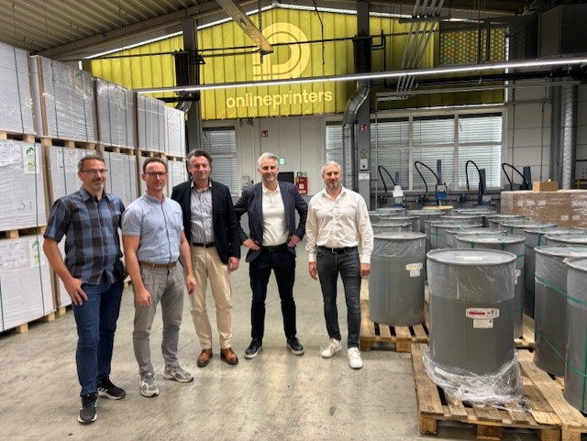
“From addressing misting and rub resistance to ongoing work on colour stability, Sun Chemical has listened to our feedback and actively adapted the inks over time. While some aspects of performance are still being refined, the continuous engagement between the two teams demonstrates a proactive, co-development approach that distinguishes Sun Chemical from other suppliers.
“There are longer-term topics we’re already discussing - including how to handle disposal and material compliance in more sustainable ways,” said Stefan. “We appreciate that Sun Chemical is not just reacting to change, but actively preparing for it.”
The relationship between Online Printers and Sun Chemical represents a modern supplier-partner dynamic, built not on promises, but on practical, day-to-day alignment. From technical service to product adaptation, and from joint problem-solving to forward-looking sustainability efforts, the partnership continues to evolve in line with the market.
The caption for the image is: (From left to right): Holger Wägner, Deputy Divisional Management Offset Printing, Onlineprinters, Stefan Hagen, Divisional Management Offset Printing, Onlineprinters, Michael Gebhardt, Sales Representative Packaging Solutions, Sun Chemical, James Buchanan, Product Director Sheetfed Systems, Sun Chemical and Ralf Schraud, Director of Operations, Onlineprinters
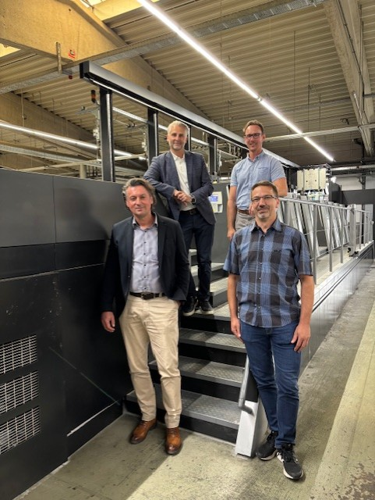
“We see this as a long-term collaboration,” concluded Stefan. “Sun Chemical brings not only the product performance we require but also the responsiveness, integrity, and willingness to grow with us that the market demands.”
James Buchanan, Product Director - Sheetfed Systems at Sun Chemical, comments: “Our partnership with Onlineprinters exemplifies the kind of customer relationship we strive for – transparent, forward-thinking, and grounded in real-world performance. From the development of SunLit ProPace to our ongoing technical and sustainability efforts, we are proud to work alongside a partner that challenges us and wants to innovate and grow with us.”
To learn more about Sun Chemical's SunLit solutions, visit: www.sunchemical.com/graphics-product-sunlit/
The caption for the image is: (Top row): James Buchanan, Product Director Sheetfed Systems, Sun Chemical and Stefan Hagen, Divisional Management Offset Printing, Onlineprinters. (Bottom row): Michael Gebhardt, Sales Representative Packaging Solutions, Sun Chemical and Holger Wägner, Deputy Divisional Management Offset Printing, Onlineprinters

ENDS

About Sun Chemical
Sun Chemical, a member of the DIC Group, is a leading producer of packaging and graphic solutions, color and display technologies, functional products, electronic materials, and products for the automotive and healthcare industries. Together with DIC, Sun Chemical is continuously working to promote and develop sustainable solutions to exceed customer expectations and better the world around us. With combined annual sales of more than $7 billion and 21,000+ employees worldwide, the DIC Group companies support a diverse collection of global customers.
Sun Chemical Corporation is a subsidiary of Sun Chemical Group Coöperatief U.A., the Netherlands, and is headquartered in Parsippany, New Jersey, U.S.A. For more information, please visit our website at www.sunchemical.com or connect with us on LinkedIn, or Instagram.

About Onlineprinters
Onlineprinters is one of Europe's leading online printing companies. Business customers can choose from over 5,000 products and configure them individually via the online shop around the clock. Production is climate-neutral in six European countries. More than 1,700 printing experts ensure the highest quality, fast delivery times and excellent service.

