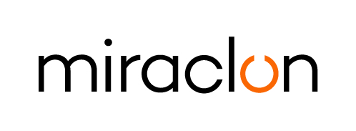
Press Release

Media contact:
Elni Van Rensburg – +1 830 317 0950 – elni.vanrensburg@miraclon.com
Imogen King - +44 (0) 7425 345 934 – iking@adcomms.co.uk

January 21st, 2026

Miraclon strengthens presence in Finland

Miraclon today announced a strategic change in its go-to-market approach in Finland, strengthening its presence by transitioning to serve the Finnish market directly. The move reflects the company’s continued commitment to supporting printers and trade shops with deeper technical engagement, faster response times, and direct access to the expertise that enables customers to fully leverage FLEXCEL NX Technology to unlock the power of modern flexo.

FLEXCEL NX Technology is brought to life in a fully integrated, end-to-end flexo platemaking system from Miraclon, designed to deliver precise, consistent imaging and optimized ink transfer through advanced plate materials, equipment, software, and multi-form surface patterning. It provides the control and predictability that enables efficient, high-quality, modern flexo printing across a wide range of applications.

“Finland has a proud and technically sophisticated flexo printing community, with a strong reputation for quality and a growing appetite for innovation,” said Stephen McCartney, Commercial Director for Europe, Africa and Middle East, Miraclon. “As the flexible packaging market continues to expand, driven by sustainability demands, SKU proliferation, and brand expectations, Finnish printers are well-positioned to accelerate their adoption of modern flexo practices.

“Going forward, we can work more closely with customers to maximize the potential of FLEXCEL NX Technology and the wider packaging production ecosystem. It is about more than plates; it’s about enabling a controlled, predictable, high-performance print process that delivers consistent results day after day. This shift allows us to bring our technical expertise, process-driven approach, and application knowledge directly to Finnish printers, supporting their growth and strengthening the competitiveness of the region’s flexible packaging industry.”

What Modern Flexo means for the packaging production market

Modern flexo is a standardized, sustainable manufacturing process where:
- Flexo can achieve visual parity with gravure, offset and digital
- Results are consistent and predictable enough to enable printing by numbers
- Jobs are printed with as few colors as possible (more process, less spots)
- Print conditions offer wide print latitude and facilitate clean printing
- Outcomes can be optimized in more challenging environments, including — crucially — with more sustainable materials

As a result, printers that implement modern flexo benefit from increased uptime, reduced waste, and more efficient job scheduling while meeting the full range of client demands.

ENDS

About Miraclon
At Miraclon, we have one clear mission - to transform flexographic printing in partnership with our customers by delivering leading technology and expertise that enables them to achieve their efficiency, sustainability and quality goals. Our unique, fully integrated FLEXCEL plate solutions eliminate production variables and deliver the 100% precision required for optimized ink transfer: the foundation of modern flexo printing. Our dedicated team helps customers achieve business success by realizing the full potential of their investment in Miraclon technology. Find out more at www.miraclon.com, and follow us on LinkedIn and YouTube.

