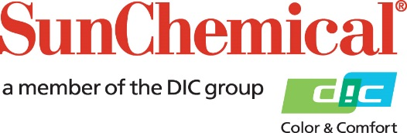

PR Contacts:
Begoña Louro, Sun Chemical Sirah Awan, AD Communications, UK
+49 152 2292 2292 +44 (0)1372 460542
begona.louro@sunchemical.com sawan@adcomms.co.uk

Sun Chemical introduces solvent-free ULM adhesive for sustainable flexible packaging

SOUTH NORMANTON, UK – 20th January 2026 – Sun Chemical today announces the launch of a new SunLam solvent-free ultra-low monomer (ULM) adhesive, designed for packaging producers in search of high-performance applications that offer a sustainable alternative to existing solvent-based adhesives.

Officially titled SunLam QA-8000+HA450, the new adhesive is part of Sun Chemical’s proprietary ULM technology. The adhesive extends its capabilities to meet the needs of flexible packaging manufacturers producing high-end applications such as extended boiling-pasteurisation, hot-filling, low-retort packaging and products that require improved chemical resistance in acidic or alcoholic environments.

Engineered for high-performance applications, the new product:
- Helps reduce energy consumption and CO₂ emissions: its VOC-free formulation has no drying requirements on a laminator.
- Supports lightweighting and facilitates mechanical recyclability for mono-material packaging thanks to a lower coating weight compared to solvent-based technology.
- Offers easy processability and fast bond strength development
- Features excellent thermal resistance and lay-down on printed substrates

SunLam QA-8000+HA450 has been fully tested in combination with Sun Chemical’s full polyurethane (PU) solvent-based inks technology and also works seamlessly with Sun Chemical’s Aqualam water-based inks to ensure compatibility for retort applications.

Nicolas Bétin, Director of Product Strategy EMEA, Packaging Inks & Materials, comments: “We’re delighted to launch SunLam QA-8000+HA450, which offers packaging producers an energy-efficient alternative that delivers the performance required for high-end packaging. This product underscores our commitment to providing customers with a portfolio that balances efficiency and safety with sustainability demands. At Sun Chemical, we are proud to offer a range of full PU and non-solvent technologies for adhesive and ink solutions.

To learn more about Sun Chemical’s solutions, visit: https://www.sunchemical.com/packaging_product_sunlam/

ENDS

About Sun Chemical
Sun Chemical, a member of the DIC Group, is a leading producer of packaging and graphic solutions, color and display technologies, functional products, electronic materials, and products for the automotive and healthcare industries. Together with DIC, Sun Chemical is continuously working to promote and develop sustainable solutions to exceed customer expectations and better the world around us. With combined annual sales of more than $8.5 billion and 22,000+ employees worldwide, the DIC Group companies support a diverse collection of global customers.

Sun Chemical Corporation is a subsidiary of Sun Chemical Group Coöperatief U.A., the Netherlands, and is headquartered in Parsippany, New Jersey, U.S.A. For more information, please visit our website at www.sunchemical.com or connect with us on LinkedIn, or Instagram.

