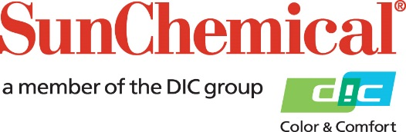

PR Contacts:
Nick Stacy, Sun Chemical Sirah Awan, AD Communications, UK
+1 859 628 2045 +44 (0)1372 460542
nick.stacy@sunchemical.com sawan@adcomms.co.uk

Sun Chemical to invest in quinacridone production in Newport, Delaware

Parsippany, NJ – February 17th 2026 – Sun Chemical, a subsidiary of DIC Corporation, will invest approximately US $10 million in its Newport, Delaware facility, to expand quinacridone pigment production capacity.

The investment will continue the reliability and supply of Sun’s industry leading quinacridone pigments. The project will optimize production performance by combining Sun Chemical’s proprietary and unique manufacturing processes with targeted site upgrades.

“Our continued investment in core chemistries, such as quinacridones, reflects our long-term commitment to supporting our customers and the market,” commented Alex Baron, Vice President, Color Materials, Sun Chemical. “This investment will improve plant safety while ensuring an uninterrupted supply of high quality quinacridones.”

Brian Panczyk, President, Color Materials, Sun Chemical, added: “As part of our ongoing journey to improve reliability and operational excellence, we remain focused on expanding and modernizing our manufacturing sites. Investments such as this ensure that we are well positioned to meet evolving customer needs while maintaining high environmental and performance standards.”

The Newport investment forms part of Sun Chemical’s broader strategy to strengthen its global manufacturing footprint and reinforce its leadership in high-performance color materials.

ENDS

About Sun Chemical
Sun Chemical, a member of the DIC Group, is a leading producer of packaging and graphic solutions, color and display technologies, functional products, electronic materials, and products for the automotive and healthcare industries. Together with DIC, Sun Chemical is continuously working to promote and develop sustainable solutions to exceed customer expectations and better the world around us. With combined annual sales of more than $7 billion and 21,000+ employees worldwide, the DIC Group companies support a diverse collection of global customers.
Sun Chemical Corporation is a subsidiary of Sun Chemical Group Coöperatief U.A., the Netherlands, and is headquartered in Parsippany, New Jersey, U.S.A. For more information, please visit our website at www.sunchemical.com or connect with us on LinkedIn, or Instagram.

