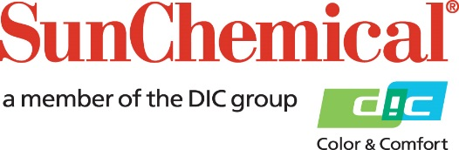

PR Contacts:
Nick Stacy, Sun Chemical Sirah Awan, AD Communications, UK
+1 859 628 2045 +44 (0)1372 460542
nick.stacy@sunchemical.com sawan@adcomms.co.uk

MEDIA ADVISORY
AD Communications appointed PR and Communications representative for Sun Chemical in North America
Parsippany, NJ – 9th February 2026– AD Communications, an integrated communications agency specialising in the print and packaging sectors, has been appointed as the PR and communications representative for Sun Chemical in North America.
AD Communications has worked with Sun Chemical for more than 15 years, delivering PR and communications support for the Packaging and Graphics portfolio of products and services across the EMEA region. More recently, it has also begun to support Sun Chemical’s Color Materials division. This new appointment now extends the two companies’ long-standing partnership to include North America.
For press enquiries going forward, or to request a comment from Sun Chemical experts on a range of topics, please contact: sunchemical@adcomms.co.uk
Sun Chemical spokespeople are available for expert comment on a range of topical issues across the packaging and graphic arts sectors, including:
- Ink and coating technologies across a wide range of sectors
- Sustainability
- Compliance and legislation
- Color management
- Food safety and low-migration solutions
- Materials and formulation innovation
- Digital and conventional technologies
- Brand and converter trends and requirements
- Print quality and performance
- Performance testing and validation

ENDS

About Sun Chemical
Sun Chemical, a member of the DIC Group, is a leading producer of packaging and graphic solutions, color and display technologies, functional products, electronic materials, and products for the automotive and healthcare industries. Together with DIC, Sun Chemical is continuously working to promote and develop sustainable solutions to exceed customer expectations and better the world around us. With combined annual sales of more than $8.5 billion and 22,000+ employees worldwide, the DIC Group companies support a diverse collection of global customers.

Sun Chemical Corporation is a subsidiary of Sun Chemical Group Coöperatief U.A., the Netherlands, and is headquartered in Parsippany, New Jersey, U.S.A. For more information, please visit our website at www.sunchemical.com or connect with us on LinkedIn, or Instagram.

