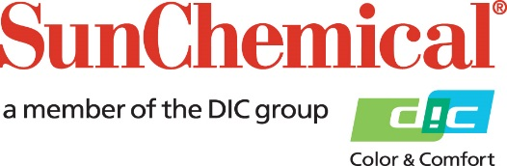

PR Contacts:
Nick Stacy, Sun Chemical Sirah Awan, AD Communications, UK
+1 859 628 2045 +44 (0)1372 460542
nick.stacy@sunchemical.com sawan@adcomms.co.uk

Sun Chemical implements price increases across all product divisions

PARSIPPANY, N.J., USA – March 19th 2026 – Sun Chemical will implement price increases and surcharges across all its product divisions, effective immediately.

These adjustments result from ongoing geopolitical developments in the Middle East, notably the situation involving Iran, which are significantly impacting global energy markets, logistics routes, and chemical feedstock availability. Like many companies, Sun Chemical is experiencing:

• Steep raw materials and intermediates price increases driven by volatility and availability in oil and gas supply.
• Higher transportation, logistics and insurance costs, particularly for shipments through critical trade routes.
• Longer lead times caused by disruptions in supply chains, affecting availability and reliability.
• Higher energy costs, and significantly higher in certain regions.

We are in close contact with our suppliers and service providers to identify product production risks and to assess how to mitigate cost increases to the greatest extent possible. Despite our continuous effort, the cumulative increases of costs, fees, and expenses, caused by aforementioned factors outside our control, necessitate price increases and surcharges to safeguard supply continuity and maintain quality and service standards.

Sun Chemical will communicate specific price increases and surcharge information directly to its customers and provide them with updates as the situation in the Middle East evolves.

Customers with questions can contact their local Sun Chemical sales representative.

ENDS

About Sun Chemical
Sun Chemical, a member of the DIC Group, is a leading producer of packaging and graphic solutions, color and display technologies, functional products, electronic materials, and products for the automotive and healthcare industries. Together with DIC, Sun Chemical is continuously working to promote and develop sustainable solutions to exceed customer expectations and better the world around us. With combined annual sales of more than $7 billion and 21,000+ employees worldwide, the DIC Group companies support a diverse collection of global customers.
Sun Chemical Corporation is a subsidiary of Sun Chemical Group Coöperatief U.A., the Netherlands, and is headquartered in Parsippany, New Jersey, U.S.A. For more information, please visit our website at www.sunchemical.com or connect with us on LinkedIn, or Instagram.

