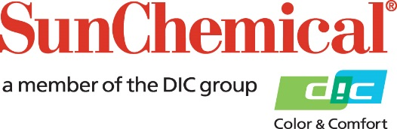

PR Contacts:
Nick Stacy, Sun Chemical Sirah Awan, AD Communications, UK
+1 859 628 2045 +44 (0)1372 460542
nick.stacy@sunchemical.com sawan@adcomms.co.uk

Sun Chemical to Showcase “Experience. Transformation.” at interpack 2026

SOUTH NORMANTON, UK – 16 March 2026 – Sun Chemical, a global leader in packaging materials and services will bring a bold new vision to interpack 2026 with Experience. Transformation. An immersive demonstration of how materials expertise, data insight and strategic services combine to create sustainable growth across the packaging value chain.

Building on the 2023 theme, Transform with Sustainable Packaging, Sun Chemical will reveal an expanded value proposition, one that aligns performance materials in inks, coatings and adhesives with strategic consulting, digital capability and innovation to help customers transform packaging challenges into powerful commercial opportunities.

At interpack 2026, visitors will discover:

- A unified materials + services proposition demonstrating how Sun Chemical supports brand evolution, efficiency, risk mitigation and sustainability through the 4Elements methodology.

- Transformation in action - explore our full suite of inks, coatings, adhesives - technologies engineered to deliver performance, efficiency and trust.

- Sun Chemical Insight Lab, a bridge between strategy and execution, offering delegates an exclusive opportunity to learn more about packaging legislation, packaging design trends, color management and insights into the future of packaging.

- Personalized, expert-led experiences that connect each visitor to the right subject matter expert and the right opportunity for growth.

“interpack 2026 marks the next chapter in our evolution, from trusted materials provider to complete solutions and services partner,” said Mehran Yazdani, President, Global Packaging and Specialties. “We invite visitors to share their greatest packaging challenge or opportunity and discover how we can help them transform.”

Join Sun Chemical at interpack 2026, Hall 7A, and Experience. Transformation.
For updates, visit: https://www.sunchemical.com/interpack-2026/

ENDS

About Sun Chemical
Sun Chemical, a member of the DIC Group, is a leading producer of packaging and graphic solutions, color and display technologies, functional products, electronic materials, and products for the automotive and healthcare industries. Together with DIC, Sun Chemical is continuously working to promote and develop sustainable solutions to exceed customer expectations and better the world around us. With combined annual sales of more than $7 billion and 21,000+ employees worldwide, the DIC Group companies support a diverse collection of global customers.
Sun Chemical Corporation is a subsidiary of Sun Chemical Group Coöperatief U.A., the Netherlands, and is headquartered in Parsippany, New Jersey, U.S.A. For more information, please visit our website at www.sunchemical.com or connect with us on LinkedIn, or Instagram.

