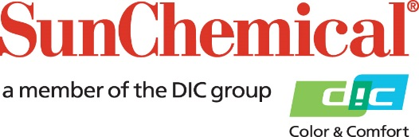

PR Contacts:
Nick Stacy, Sun Chemical Sirah Awan, AD Communications, UK
+1 859 628 2045 +44 (0)1372 460542
nick.stacy@sunchemical.com sawan@adcomms.co.uk

Sun Chemical to present advanced functional solutions at Techtextil 2026

SOUTH NORMANTON, UK – 15th April, 2026 – Sun Chemical will showcase its latest polymer innovations for artificial leather, textile coatings, and advanced bonding solutions at Techtextil 2026, taking place April 21–24, 2026, in Frankfurt, Germany.

Exhibiting at Hall 11.0, booth E46, the company will present a comprehensive portfolio of water-based polyurethane dispersions, thermoreversible adhesives, acrylic resins, and performance enhancers designed to support more efficient and sustainable textile manufacturing.

Featured technologies include the Hydran® GP and WL Series, water-based polyurethane dispersions for artificial leather applications, delivering excellent mechanical performance and enhanced process flexibility. Sun Chemical will also present Rexin® TP 65 EX and Ucoflex® 637 EA, thermoreversible adhesive solutions that deliver reliable bonding for fabrics, artificial leather, and UV printed surfaces.

Additional solutions being showcased include Ucoflex® 630 IB, a flexibilizer that enhances durability and softness, Hydrorene® AW1, a polyisocyanate bonding enhancer for textile substrates, and the Watersol® AC Series, a range of water-based acrylic resins for textile coating applications. Together, these solutions address evolving industry demands for performance, versatility, and regulatory alignment.

“Techtextil provides an important platform to engage with textile and artificial leather manufacturers seeking advanced material solutions,” said Cristian Furiosi, Functional Products EMEA, NA&LA Leader, Sun Chemical. “Our portfolio supports innovation across coating, lamination, printing, and bonding processes while enabling customers to optimize both performance and production efficiency. We look forward to welcoming visitors to our booth and sharing insights.”

Visitors to the Sun Chemical booth will have the opportunity to explore product samples, discuss application challenges with technical experts, and learn how these polymer solutions can be tailored to specific end-use requirements.

To learn more about Sun Chemical’s polymer solutions, visit Hall 11.0, Booth E46, at Techtextil in Frankfurt from April 21–24, 2026.

ENDS

About Sun Chemical
Sun Chemical, a member of the DIC Group, is a leading producer of packaging and graphic solutions, color and display technologies, functional products, electronic materials, and products for the automotive and healthcare industries. Together with DIC, Sun Chemical is continuously working to promote and develop sustainable solutions to exceed customer expectations and better the world around us. With combined annual sales of more than $7 billion and 21,000+ employees worldwide, the DIC Group companies support a diverse collection of global customers.
Sun Chemical Corporation is a subsidiary of Sun Chemical Group Coöperatief U.A., the Netherlands, and is headquartered in Parsippany, New Jersey, U.S.A. For more information, please visit our website at www.sunchemical.com or connect with us on LinkedIn, or Instagram.

