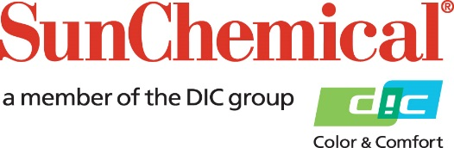

PR Contacts:
Nick Stacy, Sun Chemical Sirah Awan, AD Communications, UK
+1 859 628 2045 +44 (0)1372 460542
nick.stacy@sunchemical.com sawan@adcomms.co.uk

Sun Chemical to showcase latest masterbatch solutions at Kuteno 2026

PARSIPPANY, N.J., USA – May 13, 2026 – Sun Chemical will present its latest masterbatch innovations for plastics applications at Kuteno 2026 on booth 20, Hall 5 at Messezentrum Bad Salzuflen, Bad Salzuflen, Germany (9–11 June 2026). Sun Chemical’s broad Masterbatch portfolio is designed to help converters and brand owners achieve consistent, high-quality coloration and performance across multiple polymer systems and end uses.

Sun Chemical will showcase its product brands:

- Sicolen® – Color Masterbatches for PE and PP, offering a wide color spectrum, tailor-made formulations and suitability for diverse applications.
- Sicoversal® – Color Masterbatches for engineering plastics, developed for high-performance applications requiring precise color and formulation control.
- Sicovinyl® – Color Masterbatches for PVC, optimized for dispersion and processing behavior in PVC applications.
- Sicoplast® – Dry blends, customized for specific processing requirements with flexible, application-oriented formulations.

Kai Sörensen, Masterbatch Managing Director at Sun Chemical, comments: “Visitors to our booth will learn how we support customers through our strong formulation expertise, responsive technical service, and access to one of the world’s broadest pigment portfolios. Customers increasingly need reliable partners who can deliver consistent quality, technical collaboration, and speed, without compromising on performance. At Sun Chemical, we work closely with customers, acting as a trusted partner. Kuteno 2026 provides a great opportunity to showcase our masterbatch solutions, connect with customers and share insights within the industry. We look forward to welcoming visitors to our booth.”

To learn more about Sun Chemical’s Masterbatch portfolio, visit booth 20, hall 5 at Kuteno 2026, 09–11 June 2026, in Bad Salzuflen, Germany, or visit: https://www.sunchemical.com/masterbatch/

ENDS

About Sun Chemical
Sun Chemical, a member of the DIC Group, is a leading producer of packaging and graphic solutions, color and display technologies, functional products, electronic materials, and products for the automotive and healthcare industries. Together with DIC, Sun Chemical is continuously working to promote and develop sustainable solutions to exceed customer expectations and better the world around us. With combined annual sales of more than $7 billion and 21,000+ employees worldwide, the DIC Group companies support a diverse collection of global customers.
Sun Chemical Corporation is a subsidiary of Sun Chemical Group Coöperatief U.A., the Netherlands, and is headquartered in Parsippany, New Jersey, U.S.A. For more information, please visit our website at www.sunchemical.com or connect with us on LinkedIn, or Instagram.

