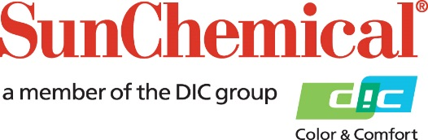

PR Contacts:
Nick Stacy, Sun Chemical Sirah Awan, AD Communications, UK
+1 859 628 2045 +44 (0)1372 460542
nick.stacy@sunchemical.com sawan@adcomms.co.uk

Sun Chemical launches SunGame™ for high-speed trading card manufacturing

Parsippany, NJ – 26th May 2026 – Sun Chemical will launch SunGame™, a product line specifically for the fast-growing trading card and gaming industry, consisting of high-quality inks, durable coatings, advanced brand protection solutions and innovative smart packaging concepts. The range supports high-speed, vibrant color and high-quality output while meeting stringent toy safety requirements.
The range enables exceptional visual appeal, smooth application and consistent color reproduction in high-speed production environments. It also offers fast setting with minimal misting to reduce ink overspray and deliver sharper images. Its low-VOC formulations reduce adverse environmental impact, while its full compliance with strict industry toy safety standards ensures suitability for products intended for children and collectors alike.
Kim Barham, Business Development Executive, Sun Chemical, comments: “The trading card and board game market continues to grow, which is driven by collector culture and rising consumer popularity. This ink was purpose-built for the industry, where speed, vibrancy and durability are non-negotiable. Thanks to its rapid color development, quick setting and minimal misting, the range is optimized for high-speed print runs that demand precision. Whether running perfecting or straight presses, the ink adapts to existing workflows and delivers results that collectors and gamers will love.”

To learn more about Sun Chemical’s SunGame™ solution, visit: https://www.sunchemical.com/sungame/

ENDS

About Sun Chemical
Sun Chemical, a member of the DIC Group, is a leading producer of packaging and graphic solutions, color and display technologies, functional products, electronic materials, and products for the automotive and healthcare industries. Together with DIC, Sun Chemical is continuously working to promote and develop sustainable solutions to exceed customer expectations and better the world around us. With combined annual sales of more than $7 billion and 21,000+ employees worldwide, the DIC Group companies support a diverse collection of global customers.
Sun Chemical Corporation is a subsidiary of Sun Chemical Group Coöperatief U.A., the Netherlands, and is headquartered in Parsippany, New Jersey, U.S.A. For more information, please visit our website at www.sunchemical.com or connect with us on LinkedIn, or Instagram.

