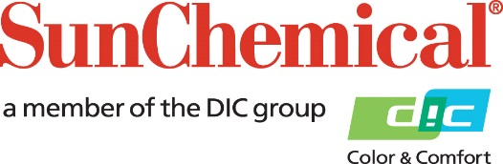

PR Contacts:
Nick Stacy, Sun Chemical Sirah Awan, AD Communications, UK
+1 859 628 2045 +44 (0)1372 460542
nick.stacy@sunchemical.com sawan@adcomms.co.uk

Sun Chemical to showcase natural color innovations at IFT FIRST 2026

PARSIPPANY, N.J., USA – June 15th, 2026 - Sun Chemical will showcase its latest natural color innovations for food and beverage applications at IFT FIRST, taking place July 12–15, 2026, at McCormick Place in Chicago, Illinois. At booth 2581, the company will highlight a portfolio of high-performance natural color solutions designed to help manufacturers meet growing consumer demand for clean-label, vibrant, and stable products.
During the event, Sun Chemical will feature LINABLUE® G1 Spirulina Extract, a premium phycocyanin solution produced through a fully integrated vertical supply chain, ensuring exceptional purity, color strength, and quality control. The company will also present its California-Grown Spirulina, backed by over 50 years of expertise in optimized cultivation, harvesting, and drying processes to deliver consistent, high-quality natural ingredients.
In addition, Sun Chemical will highlight its SUNFOODS™ natural color portfolio, including brown solutions that offer effective alternatives where caramel colors must be avoided, as well as beet-based and anthocyanin color solutions providing a wide range of shades, formats, and application versatility for food and beverage formulations.
Yangyang Jin, Business Manager, Food and Nutrition, Sun Chemical, comments: “These innovations demonstrate our commitment to helping customers solve formulation challenges while achieving the natural, appealing colors today’s consumers expect. Our expertise spans from raw material sourcing to application support, enabling us to deliver reliable, scalable natural color solutions.”
Visitors can explore prototypes containing spirulina, beet, anthocyanin, and brown color solutions and engage directly with Sun Chemical’s technical and commercial experts throughout the show.
To learn more about Sun Chemical’s natural color solutions, visit booth 2581 at IFT FIRST, July 12–15, 2026, in Chicago, Illinois, or visit: https://www.sunchemical.com/food-and-beverage/

ENDS

About Sun Chemical
Sun Chemical, a member of the DIC Group, is a leading producer of packaging and graphic solutions, color and display technologies, functional products, electronic materials, and products for the automotive and healthcare industries. Together with DIC, Sun Chemical is continuously working to promote and develop sustainable solutions to exceed customer expectations and better the world around us. With combined annual sales of more than $7 billion and 21,000+ employees worldwide, the DIC Group companies support a diverse collection of global customers.
Sun Chemical Corporation is a subsidiary of Sun Chemical Group Coöperatief U.A., the Netherlands, and is headquartered in Parsippany, New Jersey, U.S.A. For more information, please visit our website at www.sunchemical.com or connect with us on LinkedIn, or Instagram.

