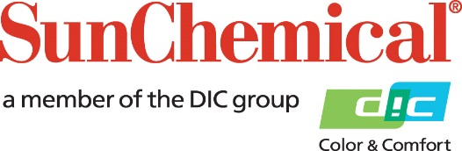

PR Contacts:
Nick Stacy, Sun Chemical Sirah Awan, AD Communications, UK
+1 859 628 2045 +44 (0)1372 460542
nick.stacy@sunchemical.com sawan@adcomms.co.uk

Sun Chemical Ecuador achieves BASC certification, Reinforcing Supply Chain Security and Compliance
PARSIPPANY, N.J., U.S.A. – July 15th, 2026 – Sun Chemical Ecuador has achieved certification from the Business Alliance for Secure Commerce (BASC), recognizing its business operations and supply chain security processes and reinforcing its commitment to secure, compliant and reliable operations.
BASC is an internationally recognised organisation that promotes secure business practices and risk prevention across the global supply chain. This prestigious certification provides an external validation of Sun Chemical Ecuador’s operational security management practices and its efforts to protect customers, suppliers and business partners through robust compliance measures.
The certification process included a comprehensive assessment of operational procedures across the organisation. Following this review, Sun Chemical Ecuador implemented enhancements to help detect and prevent risks associated with illicit activities across its supply chain commercial operations and industrial processes.
“Achieving BASC certification marks an important milestone for Sun Chemical Ecuador and reflects our ongoing commitment to operational integrity,” said Angel Córdova, General Manager, Sun Chemical Ecuador. “As a globally recognised benchmark in supply chain security management, BASC reinforces the trust our customers and suppliers place in us every day. This achievement also supports our broader corporate objectives of maintaining regulatory compliance, driving operational excellence and strengthening trusted partnerships throughout the value chain.”
Through this certification, Sun Chemical Ecuador strengthens its commitment to long-term relationships built on prevention, transparency, continuous improvement and confidence across the supply chain.

ENDS

About Sun Chemical
Sun Chemical, a member of the DIC Group, is a leading producer of packaging and graphic solutions, color and display technologies, functional products, electronic materials, and products for the automotive and healthcare industries. Together with DIC, Sun Chemical is continuously working to promote and develop sustainable solutions to exceed customer expectations and better the world around us. With combined annual sales of more than $7 billion and 21,000+ employees worldwide, the DIC Group companies support a diverse collection of global customers.
Sun Chemical Corporation is a subsidiary of Sun Chemical Group Coöperatief U.A., the Netherlands, and is headquartered in Parsippany, New Jersey, U.S.A. For more information, please visit our website at www.sunchemical.com or connect with us on LinkedIn, or Instagram.

