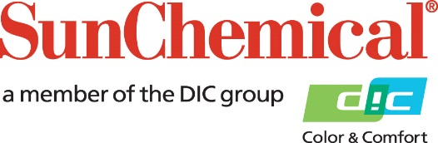

PR Contacts:
Nick Stacy, Sun Chemical Sirah Awan, AD Communications, UK
+1 859 628 2045 +44 (0)1372 460542
nick.stacy@sunchemical.com sawan@adcomms.co.uk

Sun Chemical to Showcase Innovative Pigment Preparations for Plastics at AMI Compounding & Recycling Expo 2026
PARSIPPANY, N.J., USA – August 24th, 2026 – Sun Chemical will present its latest innovations for plastics coloration and performance at the AMI Compounding & Recycling Expo 2026, taking place September 23–24, 2026 in Frankfurt, Germany. At booth F1114 in Hall 11, the company will highlight a focused portfolio of pigment preparations designed to help plastics converters improve color performance, processing efficiency, dimensional stability and visual impact.
Featured solutions will include the newest additions to the already comprehensive portfolio, including the Eupolen® NQ range for the efficient coloration of polyolefins, with a particular focus on green and blue shades. Visitors will also be able to explore how Microlen® Piano Black 0078 MCN, which combines exceptional jetness with optimised value in use, and Microlen® Pink 4410 MCN, a brighter, more chromatic pink pigment preparation engineered for polyolefins, rubber and select engineering plastics.
Sun Chemical will also showcase its Microlen® and Eupolen® non- and low-warping pigment preparations for HDPE applications such as bottle crates, pallets, containers and caps & closures. These solutions are designed to support dimensional stability while reducing the risk of distortion caused by polymer crystallisation and non-uniform shrinkage.
In addition, visitors can learn more about pigment preparations for bright colors and special effects in polyolefins, as well as Micranyl® and Microlith® solutions for PVC applications. Products on display will include Micranyl® Red 4113 Q, Micranyl® Silver 0010 G, and new pearlescent preparations from the SunMICA® FUSE range.
Christof Kujat, Global Head Industry Segment Plastics commented: “AMI is an important platform for connecting with plastics converters, brand owners and technical specialists who are looking for smarter ways to achieve color performance, process consistency and visual differentiation. Our team looks forward to showing how our pigment preparations can help deliver both aesthetics and manufacturing value.”
To learn more about Sun Chemical’s pigment preparations for plastics, visit booth F1114 in Hall 11 at AMI Compounding & Recycling Expo 2026.

ENDS

About Sun Chemical
Sun Chemical, a member of the DIC Group, is a leading producer of packaging and graphic solutions, color and display technologies, functional products, electronic materials, and products for the automotive and healthcare industries. Together with DIC, Sun Chemical is continuously working to promote and develop sustainable solutions to exceed customer expectations and better the world around us. With combined annual sales of more than $7 billion and 21,000+ employees worldwide, the DIC Group companies support a diverse collection of global customers.
Sun Chemical Corporation is a subsidiary of Sun Chemical Group Coöperatief U.A., the Netherlands, and is headquartered in Parsippany, New Jersey, U.S.A. For more information, please visit our website at www.sunchemical.com or connect with us on LinkedIn, or Instagram.

