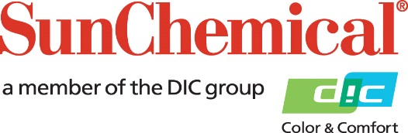

PR Contacts:
Nick Stacy, Sun Chemical Sirah Awan, AD Communications
+1 859 628 2045 +44 (0)1372 460542
nick.stacy@sunchemical.com sawan@adcomms.co.uk

Sun Chemical to showcase advanced pigment dispersions for rubber applications at IRGCE 2026

PARSIPPANY, N.J., USA – August 12th 2026 – Sun Chemical will present its latest innovations in pigment dispersions for rubber applications at IRGCE 2026, from September 8–10, 2026 in Malaysia. At booth 437, Hall 4. The company will highlight its aqueous pigment dispersions and effect products designed for dipped latex-based products such as balloons and gloves.
The portfolio features the Flexiverse range of aqueous pigment dispersions, which deliver high color strength, excellent stability and compatibility in latex systems. Flexiverse FD provides FDA compliance for dipped latex gloves and other latex products, in sensitive applications.
Sun Chemical will also showcase high-performance black dispersions, providing deep jetness and outstanding dispersion quality, which are critical for achieving consistent coloration for dipped latex goods. The company’s core competencies help manufacturers meet stringent regulatory expectations while enhancing product performance, production efficiency and consistent product quality.
Visitors will discover formulation solutions that increase color durability, chemical resistance, downstream compatibility and performance properties, addressing the specific challenges of the rubber industry. From vibrant colors and effects for balloons to compliant and reliable colors for latex gloves, Sun Chemical’s portfolio supports aesthetics, performance, and compliance needs.
“IRGCE is the best place to connect with all the key rubber and latex industry suppliers across the world. Our solutions empower our customers to deliver innovative, regulatory-compliant, and high-performance products. At the upcoming trade show, our industry experts will be available at the booth to provide live demonstrations and technical consultations”, said Shirley Shen, Global Business Director for Specialties of Sun Chemical.
To learn more about Sun Chemical’s pigment solutions for rubber and dipped latex applications, visit booth 437, Hall 4, at IRGCE, September 8–10, 2026.

ENDS

About Sun Chemical
Sun Chemical, a member of the DIC Group, is a leading producer of packaging and graphic solutions, color and display technologies, functional products, electronic materials, and products for the automotive and healthcare industries. Together with DIC, Sun Chemical is continuously working to promote and develop sustainable solutions to exceed customer expectations and better the world around us. With combined annual sales of more than $7 billion and 21,000+ employees worldwide, the DIC Group companies support a diverse collection of global customers.
Sun Chemical Corporation is a subsidiary of Sun Chemical Group Coöperatief U.A., the Netherlands, and is headquartered in Parsippany, New Jersey, U.S.A. For more information, please visit our website at www.sunchemical.com or connect with us on LinkedIn, or Instagram.

