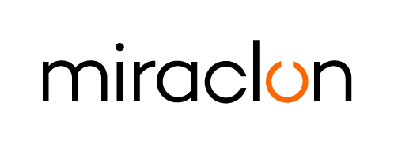
Media Alert

Media Contact:
Elni Van Rensburg: +1 830 317 0950 or elni.vanrensburg@miraclon.com
Aimee Parsons - +44 (0)1372 464470 – miraclonpr@adcomms.co.uk

September 8th, 2026

Miraclon strengthens EAMER technical leadership with appointment of Frédéric Blieck as Service Manager

Miraclon today announced the appointment of Frédéric Blieck as Service Manager for Europe, Africa and the Middle East (EAMER), strengthening its commitment to providing customers across the region with the knowledge-based services and applications expertise that help them maximize their investment in FLEXCEL Solutions and adopt modern flexo practices.

Frédéric, who has been with Miraclon for almost three years, brings more than 21 years of industry experience, which includes extensive service and commercial leadership. In his new role, he will lead the EAMER Service Team, working closely with Miraclon’s Flexo Solutions Engineers to support customers from platemaking through to the press room – combining responsive service with applications and print support that helps improve performance, consistency and productivity.

“Keeping our customers’ systems performing reliably is fundamental, but the value of our technical support goes much further,” said Robbert Merkus, Global Commercial Service Business Director, Miraclon. “Our Flexo Solutions Engineers bring together technical expertise and applications knowledge to help customers get the best from FLEXCEL Solutions in their platemaking and print production environments. Whether that means optimizing platemaking practices, supporting press trials, troubleshooting print challenges or helping implement modern flexo practices, we apply that knowledge across the print production process to help customers operate more efficiently and consistently. Frédéric has the experience, leadership and customer focus to build on that strength across the region.”

Frédéric added: “Our role doesn’t stop once a system is installed and plates are being made; we work alongside customers in the plate room and press room to help them solve print challenges, strengthen best practices and get more from FLEXCEL Solutions. My focus is to build on the knowledge we have across our EAMER team and ensure customers continue to benefit from that expertise through their production process.”

ENDS

About Miraclon
At Miraclon, we have one clear mission - to transform flexographic printing in partnership with our customers by delivering leading technology and expertise that enables them to achieve their efficiency, sustainability and quality goals. Our unique, fully integrated FLEXCEL plate solutions eliminate production variables and deliver the 100% precision required for optimized ink transfer: the foundation of modern flexo printing. Our dedicated team helps customers achieve business success by realizing the full potential of their investment in Miraclon technology. Find out more at www.miraclon.com, and follow us on LinkedIn and YouTube.

