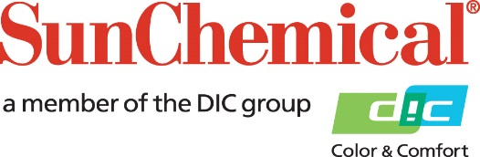

PR Contacts:
Nick Stacy, Sun Chemical Sirah Awan, AD Communications, UK
+1 859 628 2045 +44 (0)1372 460542
nick.stacy@sunchemical.com sawan@adcomms.co.uk

Sun Chemical Colors & Effects GmbH achieves AEO-C certification confirming its position as a compliant customs partner
SOUTH NORMANTON, UK – 7th October, 2026 – Sun Chemical Colors & Effects GmbH has been granted Authorised Economic Operator – Customs Simplifications (AEO-C) certification, effective 28 June 2026.
The certification, issued and granted by national customs authorities, confirms Sun Chemical’s position as a reliable and compliant customs partner and enables significant operational and financial advantages within the EU.
AEO-C is a customs certification granted to companies that demonstrate a high level of customs compliance, effective internal controls, financial solvency, proven customs competence, and operational reliability. The certification is recognized by customs authorities across all EU Member States, reinforcing Sun Chemical’s position as a trusted and reliable partner in international trade.
AEO-C status provides access to customs simplifications and operational benefits, including easier access to customs authorizations and simplifications, reduced customs controls, and priority treatment when inspections are required. It also improves cash flow, enabling faster handling and priority treatment by customs authorities.
Marc Dumont, VP Color Materials EMEA at Sun Chemical, comments: “The certification reflects our commitment to regulatory compliance, operational excellence, and the continuous improvement of our customs and trade compliance processes. For our customers in EMEA, AEO-C certification supports supply chain reliability, facilitates efficient cross-border trade, and helps reduce the risk of customs-related disruptions and delays. The benefits offered by the certification strengthen Sun Chemical’s position as a trusted business partner, enhancing its competitiveness in global supply chains.”

ENDS

About Sun Chemical
Sun Chemical, a member of the DIC Group, is a leading producer of packaging and graphic solutions, color and display technologies, functional products, electronic materials, and products for the automotive and healthcare industries. Together with DIC, Sun Chemical is continuously working to promote and develop sustainable solutions to exceed customer expectations and better the world around us. With combined annual sales of more than $7 billion and 21,000+ employees worldwide, the DIC Group companies support a diverse collection of global customers.
Sun Chemical Corporation is a subsidiary of Sun Chemical Group Coöperatief U.A., the Netherlands, and is headquartered in Parsippany, New Jersey, U.S.A. For more information, please visit our website at www.sunchemical.com or connect with us on LinkedIn, or Instagram.

