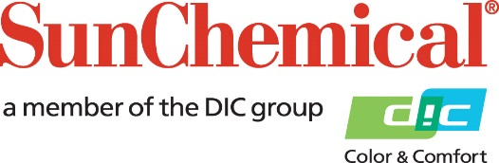

PR Contacts:
Nick Stacy, Sun Chemical Sirah Awan, AD Communications, UK
+1 859 628 2045 +44 (0)1372 460542
nick.stacy@sunchemical.com sawan@adcomms.co.uk

Sun Chemical to showcase natural food color solutions at SupplySide Global 2026

PARSIPPANY, N.J., USA – October 5, 2026 – Sun Chemical will present its latest innovations in natural food color solutions at SupplySide Global 2026, taking place October 28-30, 2026, in Las Vegas, USA. At booth 7877, the company will highlight a portfolio of natural colorants designed to help food and beverage manufacturers meet evolving consumer preferences, regulatory requirements and formulation challenges.
Featured solutions include LINABLUE® G1 spirulina extract, a premium blue color derived from vertically integrated spirulina cultivation; California-grown spirulina, supported by decades of cultivation expertise; SUNFOODS® Brown color solutions, offering alternatives where caramel colors must be avoided; SUNFOODS® Beta-Carotene, delivering vibrant yellow-to-red shades across a variety of applications; and SUNFOODS® Anthocyanins, providing stable natural colors sourced from purple sweet potatoes, black carrots and grape skins.
“Today's food and beverage manufacturers are seeking natural color solutions that combine performance, supply reliability and regulatory confidence,” said Sophia Jin, Business Manager, Food and Nutrition. “Our portfolio helps brands create visually appealing products while addressing changing market demands. We look forward to demonstrating how our natural color solutions can support innovation across a broad range of applications.”
Visitors to booth 7877 will have the opportunity to discuss formulation challenges with Sun Chemical experts and explore prototype applications featuring the company's natural color technologies.
To learn more about Sun Chemical's natural food color solutions, visit booth 7877 at SupplySide Global 2026 from October 28-30 in Las Vegas. More information is available at https://www.sunchemical.com/food-and-beverage/

ENDS

About Sun Chemical
Sun Chemical, a member of the DIC Group, is a leading producer of packaging and graphic solutions, color and display technologies, functional products, electronic materials, and products for the automotive and healthcare industries. Together with DIC, Sun Chemical is continuously working to promote and develop sustainable solutions to exceed customer expectations and better the world around us. With combined annual sales of more than $7 billion and 21,000+ employees worldwide, the DIC Group companies support a diverse collection of global customers.
Sun Chemical Corporation is a subsidiary of Sun Chemical Group Coöperatief U.A., the Netherlands, and is headquartered in Parsippany, New Jersey, U.S.A. For more information, please visit our website at www.sunchemical.com or connect with us on LinkedIn, or Instagram.

